WCF is a combined features of Web Service, Remoting, MSMQ and its a programming platform and runtime system for building, configuring and deploying network-distributed services.

**Advantage**

1. WCF is interoperable with other services when compared to .Net Remoting,where the client and service have to be .Net.
2. WCF services provide better reliability and security in compared to ASMX web services.
3. In WCF, there is no need to make much change in code for implementing the security model and changing the binding. Small changes in the configuration will make your requirements.
4. WCF has integrated logging mechanism, changing the configuration file settings will provide this functionality. In other technology developer has to write the code.

# Difference between WCF and Web service

Web service is a part of WCF. WCF offers much more flexibility and portability to develop a service when comparing to web service. Still we are having more advantages over Web service, following table provides detailed difference between them.

|  |  |  |
| --- | --- | --- |
| **Features** | **Web Service** | **WCF** |
| Hosting | It can be hosted in IIS | It can be hosted in IIS, windows activation service, Self-hosting, Windows service |
| Programming | [WebService] attribute has to be added to the class | [ServiceContraact] attribute has to be added to the class |
| Model | [WebMethod] attribute represents the method exposed to client | [OperationContract] attribute represents the method exposed to client |
| Operation | One-way, Request- Response are the different operations supported in web service | One-Way, Request-Response, Duplex are different type of operations supported in WCF |
| XML | System.Xml.serialization name space is used for serialization | System.Runtime.Serialization namespace is used for serialization |
| Encoding | XML 1.0, MTOM(Message Transmission Optimization Mechanism), DIME, Custom | XML 1.0, MTOM, Binary, Custom |
| Transports | Can be accessed through HTTP, TCP, Custom | Can be accessed through HTTP, TCP, Named pipes, MSMQ,P2P, Custom |
| Protocols | Security | Security, Reliable messaging, Transactions |

# WCF Fundamental

In this part of tutorial you are going to learn about some fundamental concepts in WCF. These concepts and terms will be used throughout this tutorial.

* [End Point](http://www.wcftutorial.net/EndPoint.aspx)
* [Bindings and Behavior](http://www.wcftutorial.net/Binding-and-Behavior.aspx)
* [Contracts and Service host](http://www.wcftutorial.net/Contracts-and-Service-Host.aspx)
* [Message and Channel](http://www.wcftutorial.net/Message-and-Channel.aspx)
* [WCF client and Metadata](http://www.wcftutorial.net/Client-and-Metadata.aspx)

# EndPoint

WCF Service is a program that exposes a collection of Endpoints. Each Endpoint is a portal for communicating with the world.

All the WCF communications are take place through end point. End point consists of three components.

**Address**

Basically URL, specifies where this WCF service is hosted .Client will use this url to connect to the service. e.g

http://localhost:8090/MyService/SimpleCalculator.svc

### Binding

Binding will describes how client will communicate with service. There are different protocols available for the WCF to communicate to the Client.You can mention the protocol type based on your requirements.

A binding has several characteristics, including the following:

* Transport -Defines the base protocol to be used like HTTP, Named Pipes, TCP, and MSMQ are some type of protocols.
* Encoding (Optional) - Three types of encoding are available-Text, Binary, or Message Transmission Optimization Mechanism (MTOM). MTOM is an interoperable message format that allows the effective transmission of attachments or large messages (greater than 64K).
* Protocol(Optional) - Defines information to be used in the binding such as Security, transaction or reliable messaging capability

The following table gives some list of protocols supported by WCF binding.

|  |  |
| --- | --- |
| **Binding** | **Description** |
| BasicHttpBinding | Basic Web service communication. No security by default |
| WSHttpBinding | Web services with WS-* support. Supports transactions |
| WSDualHttpBinding | Web services with duplex contract and transaction support |
| WSFederationHttpBinding | Web services with federated security. Supports transactions |
| MsmqIntegrationBinding | Communication directly with MSMQ applications. Supports transactions |
| NetMsmqBinding | Communication between WCF applications by using queuing. Supports transactions |
| NetNamedPipeBinding | Communication between WCF applications on same computer. Supports duplex contracts and transactions |
| NetPeerTcpBinding | Communication between computers across peer-to-peer services. Supports duplex contracts |
| NetTcpBinding | Communication between WCF applications across computers. Supports duplex contracts and transactions |

### Contract

Collection of operation that specifies what the endpoint will communicate with outside world. Usually name of the Interface will be mentioned in the Contract, so the client application will be aware of the operations which are exposed to the client. Each operation is a simple exchange pattern such as one-way, duplex and request/reply.

Below figure illustrate the functions of Endpoint

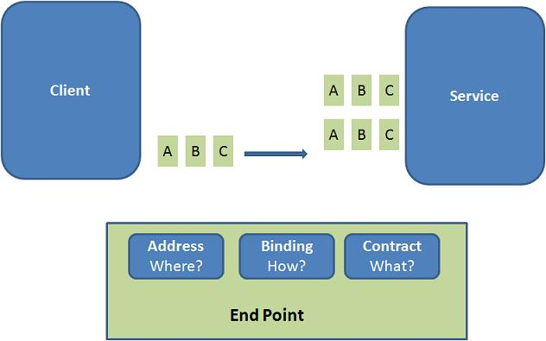

#### Example:

Endpoints will be mentioned in the web.config file on the created service.

<system.serviceModel>

<services>

<service name="MathService"

behaviorConfiguration="MathServiceBehavior">

<endpoint

address="http://localhost:8090/MyService/MathService.svc" contract="IMathService"

binding="wsHttpBinding"/>

</service>

</services>

<behaviors>

<serviceBehaviors>

<behavior name="MathServiceBehavior">

<serviceMetadata httpGetEnabled="True"/>

<serviceDebug includeExceptionDetailInFaults="true" />

</behavior>

</serviceBehaviors>

</behaviors>

</system.serviceModel>

# Binding and Behavior

### Binding

Simple definition for Binding describes how the client will communicate with service. We can understand with an example.

Consider a scenario say, I am creating a service that has to be used by two type of client. One of the client will access SOAP using http and other client will access Binary using TCP. How it can be done? With Web service it is very difficult to achieve, but in WCF its just we need to add extra endpoint in the configuration file.

<system.serviceModel>

<services>

<service name="MathService"

behaviorConfiguration="MathServiceBehavior">

<endpoint address="http://localhost:8090/MyService/MathService.svc"

contract="IMathService"

binding="wsHttpBinding"/>

<endpoint address="net.tcp://localhost:8080/MyService/MathService.svc"

contract="IMathService"

binding="netTcpBinding"/>

</service>

</services>

<behaviors>

<serviceBehaviors>

<behavior name="MathServiceBehavior">

<serviceMetadata httpGetEnabled="True"/>

<serviceDebug includeExceptionDetailInFaults="true" />

</behavior>

</serviceBehaviors>

</behaviors>

</system.serviceModel>

See how simple it is in WCF. Microsoft is making everything simple.cording to its scope: common behaviors affect all endpoints globally, service behaviors affect only service-related aspects, endpoint behaviors affect only endpoint-related properties, and operation-level behaviors affect particular operations.

#### Example:

In the below configuration information, I have mentioned the Behavior at Service level. In the service behavior I have mention the servieMetadata node with attribute httGetEnabled='true'. This attribute will specifies the publication of the service metadata. Similarly we can add more behavior to the service.

<system.serviceModel>

<services>

<service name="MathService"

behaviorConfiguration="MathServiceBehavior">

<endpoint address="" contract="IMathService"

binding="wsHttpBinding"/>

</service>

</services>

<behaviors>

<serviceBehaviors>

<behavior name="MathServiceBehavior">

<serviceMetadata httpGetEnabled="True"/>

<serviceDebug includeExceptionDetailInFaults="true" />

</behavior>

</serviceBehaviors>

</behaviors>

</system.serviceModel>

# Contracts and Service Host

## Contracts

In WCF, all services are exposed as contracts. Contract is a platform-neutral and standard way of describing what the service does. Mainly there are four types of contracts available in WCF

### Service Contract

Service contracts describe the operation that service can provide. For Eg, a Service provide to know the temperature of the city based on the zip code, this service is called as Service contract. It will be created using Service and Operational Contract attribute.

### Data Contract

Data contract describes the custom data type which is exposed to the client. This defines the data types, that are passed to and from service. Data types like int, string are identified by the client because it is already mention in XML schema definition language document, but custom created class or data types cannot be identified by the client e.g. Employee data type. By using DataContract we can make client to be aware of Employee data type that are returning or passing parameter to the method.

### Message Contract

Default SOAP message format is provided by the WCF runtime for communication between Client and service. If it is not meeting your requirements then we can create our own message format. This can be achieved by using Message Contract attribute.

### Fault Contract

Suppose the service I consumed is not working in the client application. I want to know the real cause of the problem. How I can know the error? For this we are having Fault Contract. Fault Contract provides documented view for error occurred in the service to client. This helps us to easy identity, what error has occurred.

# Service Host

Service Host object is in the process of hosting the WCF service and registering endpoints. It loads the service configuration endpoints, apply the settings and start the listeners to handle the incoming request. *System.ServiceModel.ServiceHost* namespace hold this object. This object is created while self hosting the WCF service.

In the below example you can find that WCF service is self hosted using console application.

//Creating uri for the hosting the service

Uri uri = new Uri("http://localhost/CategoryService");

//Creating the host object for MathService

ServiceHost host = new ServiceHost(typeof(CategoryService), uri);

//Adding endpoint to the Host object

host.AddServiceEndpoint(typeof(ICategoryService),new WSHttpBinding(), uri);

host.Open(); //Hosting the Service

Console.WriteLine("Waiting for client invocations");

Console.ReadLine();

host.Close();

# Message and Channel

### Message

WCF Message is the unit of data exchange between client and service. It consists of several parts, including a body and headers.

### WCF Runtime

WCF runtime is the set of object responsible for sending and receiving message. For example formatting the message, applying security and transmitting and receiving message using various protocol.

### Channels:

Channels are the core abstraction for sending message to and receiving message from an Endpoint. Broadly we can categories channels as

#### Transport Channels

**-** Handles sending and receiving message from network. Protocols like HTTP, TCP name pipes and MSMQ.

#### Protocol Channels

- Implements SOAP based protocol by processing and possibly modifying message. e.g. WS-Security and WS-Reliability.

# WCF Client and Metadata

### WCF Client

WCF client is a client application creates to expose the service operations as method. Any application can host a WCF client, including an application that host a service. Therefore it is possible to create a service that includes WCF clients of other services.

A client application is a managed application that uses a WCF client to communicate with another application. To create a client application for a WCF service requires the following steps:

1. Get the Proxy class and service end point information

Using *SvcUtil.exe* we can create proxy class for the service and configuration information for endpoints. Example type the following sentence in the Visual studio command prompt, this will generate the class file and configuration file which contain information about the endpoints.

*svcutil /language:vb /out:ClientCode.vb /config:app.config* *http://localhost:8090/MyService/SimpleCalculator.svc?wsdl*

1. Call operations.

Add this class files in the client application. Then create the object for this class and invoke the service operation. Configuration information we got from the above step has to be added to the client application configuration file. When the client application calls the first operation, WCF automatically opens the underlying channel. This underlying channel is closed, when the object is recycled.

//Creating the proxy on client side

MyCalculatorServiceProxy.MyServiceProxy proxy

= new MyCalculatorServiceProxy.MyServiceProxy();

Console.WriteLine("Counter: " + proxy.MyMethod());

1. Close the WCF client object.

After using the object created in the above steps, we have to dispose the object. Channel will be closed with the service, when the object is cleared.

### Metadata

Characteristics of the service are described by the metadata. This metadata can be exposed to the client to understand the communication with service. Metadata can be set in the service by enabling the ServiceMetadata node inside the servcieBehaviour node of the service configuration file.

<system.serviceModel>

<services>

<service name="MathService"

behaviorConfiguration="MathServiceBehavior">

<endpoint address="" contract="IMathService"

binding="wsHttpBinding"/>

</service>

</services>

<behaviors>

<serviceBehaviors>

<behavior name="MathServiceBehavior">

<serviceMetadata httpGetEnabled="True"/>

<serviceDebug includeExceptionDetailInFaults="true" />

</behavior>

</serviceBehaviors>

</behaviors>

</system.serviceModel>

This metadata can be viewed while creating WCF client application using *SvcUtil.exe*

# WCF Architecture

The following figure illustrates the major components of WCF.

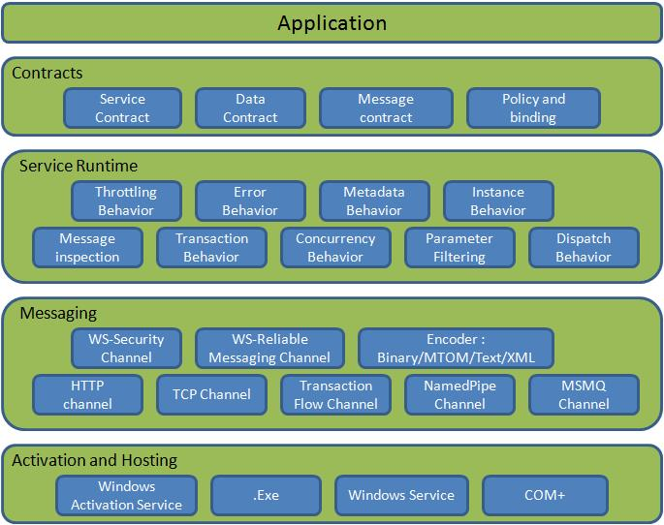

Figure 1: WCF Architecture

### Contracts

Contracts layer are next to that of Application layer. Developer will directly use this contract to develop the service. We are also going to do the same now. Let us see briefly what these contracts will do for us and we will also know that WCF is working on message system.

### Service contracts

- Describe about the operation that service can provide. Example, Service provided to know the temperature of the city based on the zip code, this service we call as Service contract. It will be created using Service and Operational Contract attribute.

### Data contract

- It describes the custom data type which is exposed to the client. This defines the data types, are passed to and from service. Data types like int, string are identified by the client because it is already mention in XML schema definition language document, but custom created class or datatype cannot be identified by the client e.g. Employee data type. By using DataContract we can make client aware that we are using Employee data type for returning or passing parameter to the method.

### Message Contract

- Default SOAP message format is provided by the WCF runtime for communication between Client and service. If it is not meeting your requirements then we can create our own message format. This can be achieved by using Message Contract attribute.

### Policies and Binding

- Specify conditions required to communicate with a service e.g security requirement to communicate with service, protocol and encoding used for binding.

### Service Runtime

- It contains the behaviors that occur during runtime of service.

* Throttling Behavior- Controls how many messages are processed.
* Error Behavior - Specifies what occurs, when internal error occurs on the service.
* Metadata Behavior - Tells how and whether metadata is available to outside world.
* Instance Behavior - Specifies how many instance of the service has to be created while running.
* Transaction Behavior - Enables the rollback of transacted operations if a failure occurs.
* Dispatch Behavior - Controls how a message is processed by the WCF Infrastructure.

### Messaging

- Messaging layer is composed of channels. A channel is a component that processes a message in some way, for example, by authenticating a message. A set of channels is also known as a channel stack. Channels are the core abstraction for sending message to and receiving message from an Endpoint. Broadly we can categories channels as

* Transport Channels

Handles sending and receiving message from network. Protocols like HTTP, TCP, name pipes and MSMQ.

* Protocol Channels

Implements SOAP based protocol by processing and possibly modifying message. E.g. WS-Security and WS-Reliability.

### Activation and Hosting

- Services can be hosted or executed, so that it will be available to everyone accessing from the client. WCF service can be hosted by following mechanism

* IIS

Internet information Service provides number of advantages if a Service uses Http as protocol. It does not require Host code to activate the service, it automatically activates service code.

* Windows Activation Service

(WAS) is the new process activation mechanism that ships with IIS 7.0. In addition to HTTP based communication, WCF can also use WAS to provide message-based activation over other protocols, such as TCP and named pipes.

* Self-Hosting

WCF service can be self hosted as console application, Win Forms or WPF application with graphical UI.

* Windows Service

WCF can also be hosted as a Windows Service, so that it is under control of the Service Control Manager (SCM).

# WCF Hosting

In this part of the tutorial we are going to see the four different way of hosting the WCF service. WCF service cannot exist on its own; it has to be hosted in windows process called as host process. Single host process can host multiple servers and same service type can be hosted in multiple host process. As we discussed there are mainly four different way of hosting the WCF service.

1. [IIS hosting](http://www.wcftutorial.net/WCF-IIS-Hosting.aspx)
2. [Self hosting](http://www.wcftutorial.net/WCF-Self-Hosting.aspx)
3. [Windows Activation Service](http://www.wcftutorial.net/WCF-WAS-Hosting.aspx)
4. [Windows Service](http://www.wcftutorial.net/WCF-Windows-Service-Hosting.aspx)

Multiple hosting and protocols supported by WCF.Microsoft has introduced the WCF concept in order to make distributed application development and deployment simple.

|  |  |
| --- | --- |
| **Hosting Environment** | **Supported protocol** |
| Windows console and form application | HTTP,net.tcp,net.pipe,net.msmq |
| Windows service application (formerly known as NT services) | HTTP,net.tcp,net.pipe,net.msmq |
| Web server IIS6 | http, wshttp |
| Web server IIS7 - Windows Process Activation Service (WAS) | HTTP,net.tcp,net.pipe,net.msmq |

A summary of hosting options and supported features.

|  |  |  |  |
| --- | --- | --- | --- |
| **Feature** | **Self-Hosting** | **IIS Hosting** | **WAS Hosting** |
| Executable Process/ App Domain | Yes | Yes | Yes |
| Configuration | App.config | Web.config | Web.config |
| Activation | Manual at startup | Message-based | Message-based |
| Idle-Time Management | No | Yes | Yes |
| Health Monitoring | No | Yes | Yes |
| Process Recycling | No | Yes | Yes |
| Management Tools | No | Yes | Yes |

# IIS 5/6 Hosting

The main advantage of hosting service in IIS is that, it will automatically launch the host process when it gets the first client request. It uses the features of IIS such as process recycling, idle shutdown, process health monitoring and message based activation. The main disadvantage of using IIS is that, it will support only HTTP protocol.

Let as do some hands on, to create service and host in IIS

**Step 1:**Start the Visual Studio 2008 and click File->New->Web Site. Select the 'WCF Service' and Location as http. This will directly host the service in IIS and click OK.

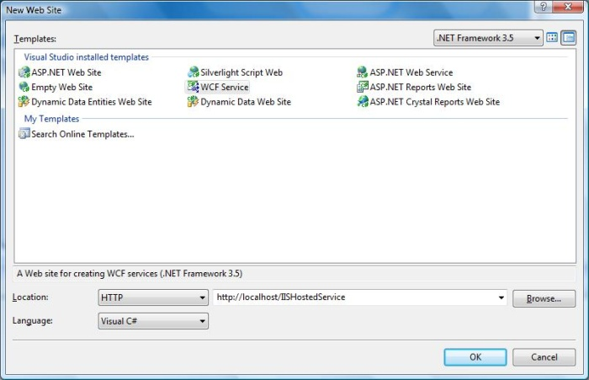

**Step 2:** I have created sample HelloWorld service, which will accept name as input and return with 'Hello' and name. Interface and implementation of the Service is shown below.

**IMyService.cs**

[ServiceContract]

public interface IMyService

{

[OperationContract]

string HelloWorld(string name);

}

**MyService.cs**

public class MyService : IMyService

{

#region IMyService Members

public string HelloWorld(string name)

{

return "Hello " + name;

}

#endregion

}

**Step 3:** Service file (.svc) contains name of the service and code behind file name. This file is used to know about the service.

**MyService.svc**

<%@ ServiceHost Language="C#" Debug="true"

Service="MyService" CodeBehind="~/App_Code/MyService.cs" %>

**Step 4:** Server side configurations are mentioned in the config file. Here I have mention only one end point which is configured to 'wsHttpBinding', we can also have multiple end point with differnet binding. Since we are going to hosted in IIS. We have to use only http binding. We will come to know more on endpoints and its configuration in later tutorial. **Web.Config**

<system.serviceModel>

<services>

<service behaviorConfiguration="ServiceBehavior" name="MyService">

<endpoint address="http://localhost/IISHostedService/MyService.svc"

binding="wsHttpBinding" contract="IMyService">

<identity>

<dns value="localhost"/>

</identity>

</endpoint>

<endpoint address="mex" binding="mexHttpBinding" contract="IMetadataExchange"/>

</service>

</services>

<behaviors>

<serviceBehaviors>

<behavior name="ServiceBehavior">

<!-- To avoid disclosing metadata information,

set the value below to false and remove the

metadata endpoint above before deployment -->

<serviceMetadata httpGetEnabled="true"/>

<!-- To receive exception details in faults for

debugging purposes, set the value below to true.

Set to false before deployment to avoid disclosing exception information -->

<serviceDebug includeExceptionDetailInFaults="false"/>

</behavior>

</serviceBehaviors>

</behaviors>

</system.serviceModel>

**Note:**

You need to mention the service file name, along with the Address mention in the config file. IIS Screen shot

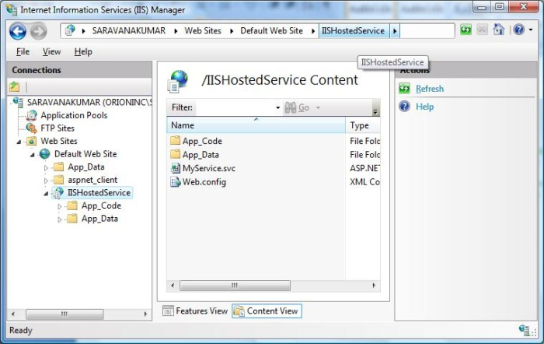

This screen will appear when we run the application.

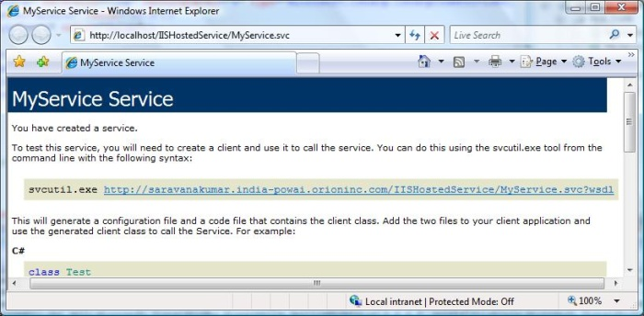

**Step 5:** Now we successfully hosted the service in IIS. Next we have to consume this service in client application. Before creating the client application, we need to create the proxy for the service. This proxy is used by the client application, to interact with service. To create the proxy, run the Visual Studio 2008 command prompt. Using service utility we can create the proxy class and its configuration information.

*svcutil http://localhost/IISHostedService/MyService.svc*

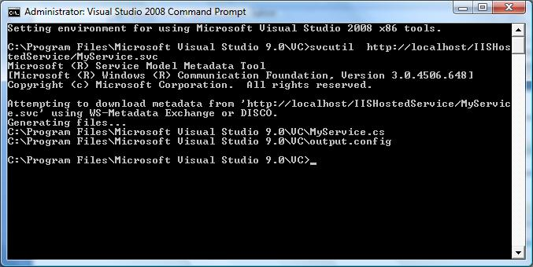

After executing this command we will find two file generated in the default location.

* MyService.cs - Proxy class for the WCF service
* output.config - Configuration information about the service.

**Step 6:** Now we will start creating the Console application using Visual Studio 2008(Client application).

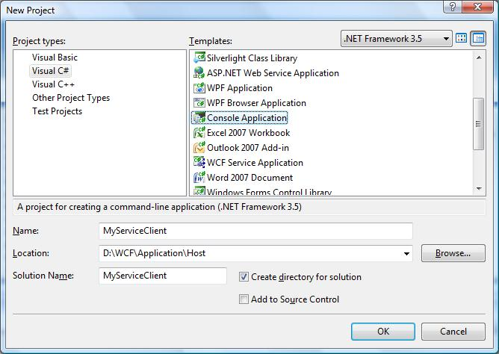

**Step 7:** Add the reference 'System.ServiceModel'; this is the core dll for WCF.

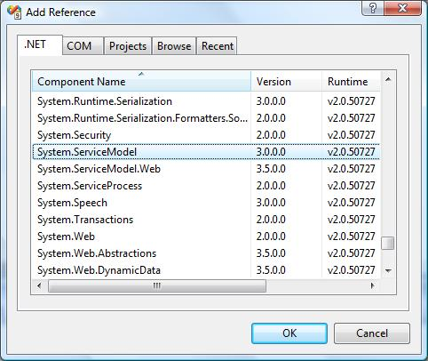

**Step 8:** Create the object for the proxy class and call the HelloWorld method.

static void Main(string[] args)

{

//Creating Proxy for the MyService

MyServiceClient client = new MyServiceClient();

Console.WriteLine("Client calling the service...");

Console.WriteLine(client.HelloWorld("Ram"));

Console.Read();

}

**Step 9:** If we run the application we will find the output as shown below.

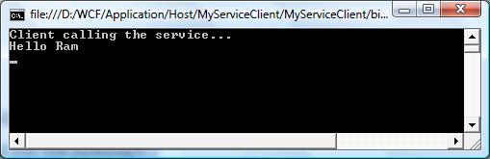

I hope you have enjoyed the Service hosted in IIS. Now let start the look on the self hosted service.

# Self Hosting

In web service, we can host the service only in IIS, but WCF provides the user to host the service in any application (e.g. console application, Windows form etc.). Very interestingly developer is responsible for providing and managing the life cycle of the host process. Service can also be in-pro i.e. client and service in the same process. Now let's us create the WCF service which is hosted in Console application. We will also look in to creating proxy using *'ClientBase'* abstract class.

**Note: Host process must be running before the client calls the service, which typically means you have to prelaunch it.**

**Step 1: First let's start create the Service contract and it implementation. Create a console application and name it as MyCalculatorService. This is simple service which return addition of two numbers.**

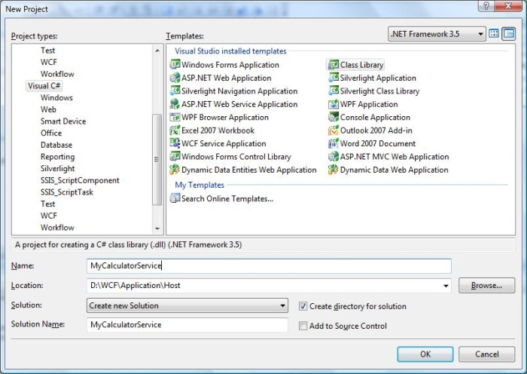

**Step 2: Add the System.ServiceModel reference to the project.**

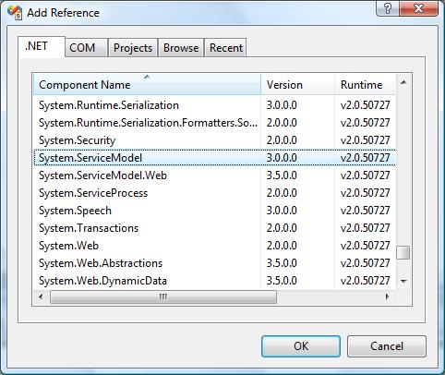

**Step 3: Create an ISimpleCalculator interface, Add ServiceContract and OperationContract attribute to the class and function as shown below. You will know more information about these contracts in later session. These contracts will expose method to outside world for using this service.**

**IMyCalculatorService.cs**

**using System;**

**using System.Collections.Generic;**

**using System.Linq;**

**using System.Text;**

**using System.ServiceModel;**

**namespace MyCalculatorService**

**{**

**[ServiceContract()]**

**public interface ISimpleCalculator**

**{**

**[OperationContract()]**

**int Add(int num1, int num2);**

**}**

**}**

**Step 4: MyCalculatorService is the implementation class for IMyCalculatorService interface as shown below.**

**MyCalculatorService.cs**

**using System;**

**using System.Collections.Generic;**

**using System.Linq;**

**using System.Text;**

**namespace MyCalculatorService**

**{**

**class SimpleCalculator : ISimpleCalculator**

**{**

**public int Add(int num1, int num2)**

**{**

**return num1 + num2;**

**}**

**}**

**}**

**Step 5: Now we are ready with service. Let's go for implementing the hosting process. Create a new console application and name it as 'MyCalculatorServiceHost'**

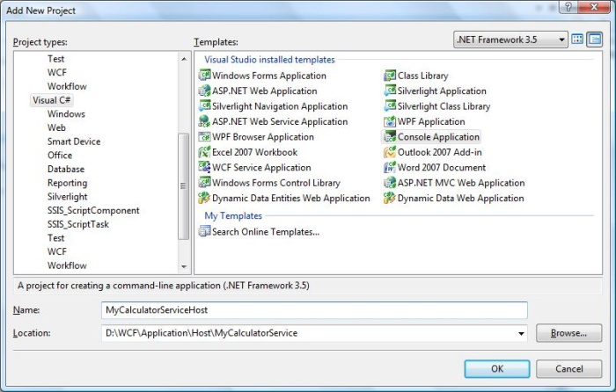

**Step 6: *ServiceHost* is the core class use to host the WCF service. It will accept implemented contract class and base address as contractor parameter. You can register multiple base addresses separated by commas, but address should not use same transport schema.**

**Uri httpUrl**

**= new Uri("http://localhost:8090/MyService/SimpleCalculator");**

**Uri tcpUrl**

**= new Uri("net.tcp://localhost:8090/MyService/SimpleCalculator");**

**ServiceHost host**

**= new ServiceHost(typeof(MyCalculatorService.SimpleCalculator), httpUrl, tcpUrl);**

**Multiple end points can be added to the Service using *AddServiceEndpoint()* method. *Host.Open()* will run the service, so that it can be used by any client.**

**Step 7: Below code show the implementation of the host process.**

**using System;**

**using System.Collections.Generic;**

**using System.Linq;**

**using System.Text;**

**using System.ServiceModel;**

**using System.ServiceModel.Description;**

**namespace MyCalculatorServiceHost**

**{**

**class Program**

**{**

**static void Main(string[] args)**

**{**

**//Create a URI to serve as the base address**

**Uri httpUrl = new Uri("http://localhost:8090/MyService/SimpleCalculator");**

**//Create ServiceHost**

**ServiceHost host**

**= new ServiceHost(typeof(MyCalculatorService.SimpleCalculator), httpUrl);**

**//Add a service endpoint**

**host.AddServiceEndpoint(typeof(MyCalculatorService.ISimpleCalculator)**

**, new WSHttpBinding(), "");**

**//Enable metadata exchange**

**ServiceMetadataBehavior smb = new ServiceMetadataBehavior();**

**smb.HttpGetEnabled = true;**

**host.Description.Behaviors.Add(smb);**

**//Start the Service**

**host.Open();**

**Console.WriteLine("Service is host at " + DateTime.Now.ToString());**

**Console.WriteLine("Host is running... Press <Enter> key to stop");**

**Console.ReadLine();**

**}**

**}**

**}**

**Step 8: Service is hosted, now we need to implement the proxy class for the client. There are different ways of creating the proxy**

* **Using SvcUtil.exe, we can create the proxy class and configuration file with end points.**
* **Adding Service reference to the client application.**
* **Implementing ClientBase<T> class**

**Of these three methods, Implementing ClientBase<T> is the best practice. If you are using rest two method, we need to create proxy class every time when we make changes in Service implementation. But this is not the case for ClientBase<T>. It will create the proxy only at runtime and so it will take care of everything.**

**MyCalculatorServiceProxy.cs**

**using System;**

**using System.Collections.Generic;**

**using System.Linq;**

**using System.Text;**

**using System.ServiceModel;**

**using MyCalculatorService;**

**namespace MyCalculatorServiceProxy**

**{**

**public class MyCalculatorServiceProxy :**

**//WCF create proxy for ISimpleCalculator using ClientBase**

**ClientBase<ISimpleCalculator>,**

**ISimpleCalculator**

**{**

**public int Add(int num1, int num2)**

**{**

**//Call base to do funtion**

**return base.Channel.Add(num1, num2);**

**}**

**}**

**}**

**Step 9: In the client side, we can create the instance for the proxy class and call the method as shown below. Add proxy assembly as reference to the project.**

**using System;**

**using System.Collections.Generic;**

**using System.Linq;**

**using System.Text;**

**using System.ServiceModel;**

**namespace MyCalculatorServiceClient**

**{**

**class Program**

**{**

**static void Main(string[] args)**

**{**

**MyCalculatorServiceProxy.MyCalculatorServiceProxy proxy ;**

**proxy= new MyCalculatorServiceProxy.MyCalculatorServiceProxy();**

**Console.WriteLine("Client is running at " + DateTime.Now.ToString());**

**Console.WriteLine("Sum of two numbers... 5+5 ="+proxy.Add(5,5));**

**Console.ReadLine();**

**}**

**}**

**}**

**Step 10 : End point (same as service) information should be added to the configuration file of the client application.**

**<?xml version="1.0" encoding="utf-8" ?>**

**<configuration>**

**<system.serviceModel>**

**<client>**

**<endpoint address ="http://localhost:8090/MyService/SimpleCalculator"**

**binding ="wsHttpBinding"**

**contract ="MyCalculatorService.ISimpleCalculator">**

**</endpoint>**

**</client>**

**</system.serviceModel>**

**</configuration>**

**Step 11: Before running the client application, you need to run the service. Output of the client application is shown below.**

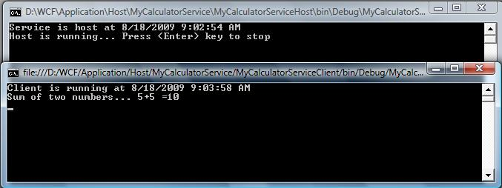

This self host shows advantage such as in-Pro hosting, programmatic access and it can be used when there need singleton service. I hope you have enjoyed the Self hosting session, now let go for hosting using Windows Activation service.

# Windows Activation Service

Windows Activation service is a system service available with Windows vista and windows server 2008. It is available with IIS 7.0 and it is more powerful compared to IIS 6.0 because it supports Http, TCP and named pipes were IIS 6.0 supports only Http. It can be installed and configured separately.

Hosting WCF in Activation service takes many advantages such as process recycling, isolation, idle time management and common configuration system. WAS hosted service can be created using following steps

1. Enable WCF for non-http protocols
2. Create WAS hosted service
3. Enable different binding to the hosted service

### Enable WCF for non-http protocols

Before Start creating the service we need to configure the system to support WAS. Following are the step to configure WAS.

1. Click Start -> Control Panel -> programs and Features and click 'Turn Windows Components On or Off' in left pane.
2. Expand 'Microsoft .Net Framework 3.0' and enable "Windows Communication Foundation HTTP Activation" and "Windows Communication Foundation Non- HTTP Activation".
3. Next we need to add Binding to the Default Web site. As an example, we will bind the default web site to the TCP protocol. Go to the Start menu -> Programs ->Accessories. Right click on the "Command Prompt" item, and select "Run as administrator" from the context menu.
4. Execute the following command
5. C:\Windows\system32\inetsrv> appcmd.exe set site "Default Web Site" -+bindings.[protocol='net.tcp', bindingInformation='808:*']
6. That command adds the net.tcp site binding to the default web site by modifying the applicationHost.config file located in the "*C:\Windows\system32\inetsrv\config*" directory. Similarly we can add different protocols to the Default Web site.

### Create WAS hosted service

**Step 1:** Next we are going to create the service, Open the Visual Studio 2008 and click New->WebSite and select WCF Service from the template and Location as HTTP as shown below.

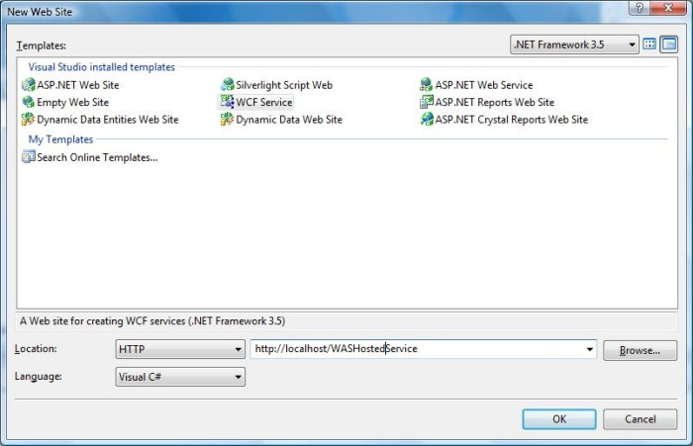

**Step 2:** Create the Contract by creating interface IMathService and add ServiceContract attribute to the interface and add OperationContract attribute to the method declaration.

**IMathService.cs**

using System;

using System.Collections.Generic;

using System.Linq;

using System.Runtime.Serialization;

using System.ServiceModel;

using System.Text;

[ServiceContract]

public interface IMathService

{

[OperationContract]

int Add(int num1, int num2);

[OperationContract]

int Subtract(int num1, int num2);

}

**Step 3:** Implementation of the IMathService interface is shown below.

**MathService.cs**

using System;

using System.Collections.Generic;

using System.Linq;

using System.Runtime.Serialization;

using System.ServiceModel;

using System.Text;

public class MathService : IMathService

{

public int Add(int num1, int num2)

{

return num1 + num2;

}

public int Subtract(int num1, int num2)

{

return num1 - num2;

}

}

**Step 4:** Service file is shown below.

**MathService.svc**

<%@ ServiceHost Language="C#" Debug="true" Service="MathService"

CodeBehind="~/App_Code/MathService.cs" %>

**Step 5:** In web.Config file, create end point with 'netTcpBinding' binding and service metadata will be published using Metadata Exchange point. So create the Metada Exchange end point with address as 'mex' and binding as 'mexTcpBinding'. Without publishing the service Metadata we cannot create the proxy using net.tcp address (e.g svcutil.exe net.tcp://localhost/WASHostedService/MathService.svc )

**Web.Config**

<system.serviceModel>

<services>

<service name="MathService" behaviorConfiguration="ServiceBehavior">

<!-- Service Endpoints -->

<endpoint binding="netTcpBinding"

contract="IMathService" >

</endpoint>

<endpoint address="mex"

binding="mexTcpBinding" contract="IMetadataExchange"/>

</service>

</services>

<behaviors>

<serviceBehaviors>

<behavior name="ServiceBehavior">

<!-- To avoid disclosing metadata information, set the value below

to false and remove the metadata endpoint above before deployment -->

<serviceMetadata httpGetEnabled="true"/>

<!-- To receive exception details in

faults for debugging purposes, set the value below to true.

Set to false before deployment to avoid disclosing

exception information -->

<serviceDebug includeExceptionDetailInFaults="false"/>

</behavior>

</serviceBehaviors></behaviors>

</system.serviceModel>

### Enable different binding to the hosted service

1. Go to the Start menu -> Programs ->Accessories. Right click on the "Command Prompt" item, and select "Run as administrator" from the context menu.
2. Execute the following command *C:\Windows\system32\inetsrv>appcmd set app "Default Web Site/WASHostedServcie" /enabledProtocols:http,net.tcp*

Output will be shown below.

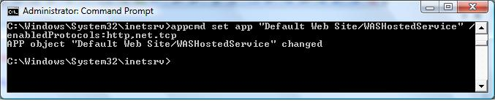

**Step 6:** Now the service is ready to use. Next we can create the proxy class using service uttility and add the proxy class to the client application. Creat the proxy class using Visual Studio Command prompt and execute the command

*svcutil.exe net.tcp://localhost/WASHostedService/MathService.svc*

Proxy and configuration file are generated in the corresponding location.

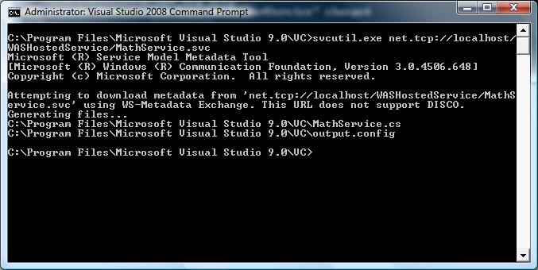

**Step 6:** Create the client application as shown below and add the reference '*System.ServiceModel*', this is the core dll for WCF.

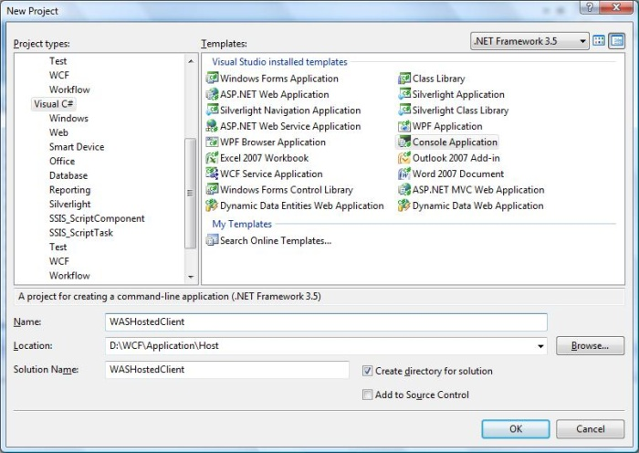

**Step 8:** Add the proxy class and configuration file to the client application. Create the object for the MathServiceClient and call the method.

**Program.cs**

class Program

{

static void Main(string[] args)

{

MathServiceClient client = new MathServiceClient();

Console.WriteLine("Sum of two number 5,6");

Console.WriteLine(client.Add(5,6));

Console.ReadLine();

}

}

The output will be shown as below.

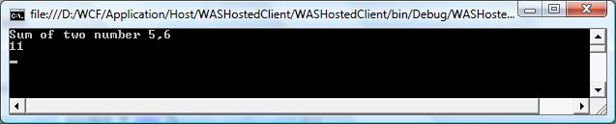

So this tutorial clearly explains about the hosting the WCF in Windows Activation Service. So next we can see how to host the service using Windows Service

# Windows Service Hosting

In this tutorial we are going to see the hosting WCF service in Windows service. We will use same set of code used for hosting the WCF service in Console application to this. This is same as hosting the service in IIS without message activated. There is some advantage of hosting service in Windows service.

* The service will be hosted, when system starts
* Process life time of the service can be controlled by Service Control Manager for windows service
* All versions of Windows will support hosting WCF service.

**Step 1:** Now let start create the WCF service, Open the Visual Studio 2008 and click New->Project and select Class Library from the template.

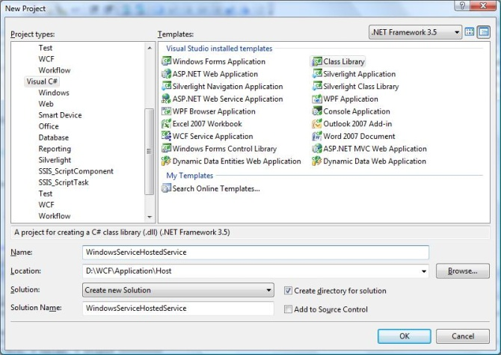

**Step 2:** Add reference *System.ServiceModel* to the project. This is the core assembly used for creating the WCF service.

**Step 3:** Next we can create the *ISimpleCalulator* interface as shown below. Add the Service and Operation Contract attribute as shown below.

**ISimpleCalculator.cs**

using System;

using System.Collections.Generic;

using System.Linq;

using System.Text;

using System.ServiceModel;

namespace WindowsServiceHostedContract

{

[ServiceContract]

public interface ISimpleCalculator

{

[OperationContract]

int Add(int num1, int num2);

[OperationContract]

int Subtract(int num1, int num2);

[OperationContract]

int Multiply(int num1,int num2);

[OperationContract]

double Divide(int num1, int num2);

}

}

**Step 4:** Implement the *ISimpleCalculator* interface as shown below.

**SimpleCalulator.cs**

using System;

using System.Collections.Generic;

using System.Linq;

using System.Text;

namespace WindowsServiceHostedService

{

class SimpleCalculator

: ISimpleCalculator

{

public int Add(int num1, int num2)

{

return num1+num2;

}

public int Subtract(int num1, int num2)

{

return num1-num2;

}

public int Multiply(int num1, int num2)

{

return num1*num2;

}

public double Divide(int num1, int num2)

{

if (num2 != 0)

return num1 / num2;

else

return 0;

}

}

}

**Step 5:** Build the Project and get the dll. Now we are ready with WCF service, now we are going to see how to host the WCF Service in Windows service. **Note:** In this project, I have mention that we are creating both Contract and Service(implementation) are in same project. It is always good practice if you have both in different project.

**Step 6:** Open Visual Studio 2008 and Click New->Project and select Windows Service.

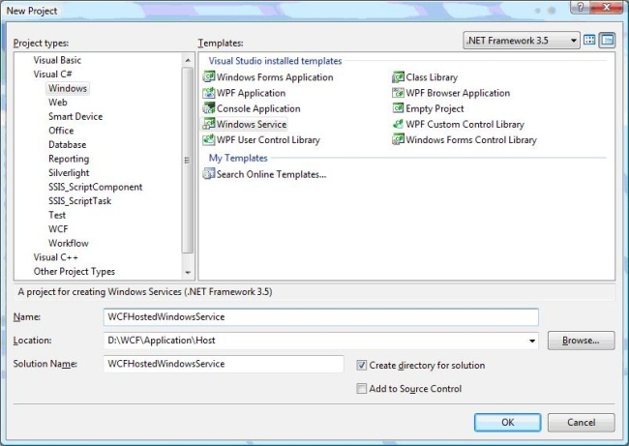

**Step 7:** Add the '*WindowsServiceHostedService.dll*' as reference to the project. This assembly will going to act as service.

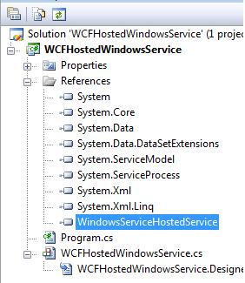

**Step 8:** OnStart method of the service, we can write the hosting code for WCF. We have to make sure that we are using only one service host object. On stop method you need to close the Service Host. Following code show how to host WCF service in Windows service.

**WCFHostedWindowsService.cs**

using System;

using System.Collections.Generic;

using System.ComponentModel;

using System.Data;

using System.Diagnostics;

using System.Linq;

using System.ServiceProcess;

using System.Text;

using System.ServiceModel;

using System.ServiceModel.Description;

namespace WCFHostedWindowsService

{

partial class WCFHostedWindowsService : ServiceBase

{

ServiceHost m_Host;

public WCFHostedWindowsService()

{

InitializeComponent();

}

protected override void OnStart(string[] args)

{

if (m_Host != null)

{

m_Host.Close();

}

//Create a URI to serve as the base address

Uri httpUrl = new Uri("http://localhost:8090/MyService/SimpleCalculator");

//Create ServiceHost

m_Host = new ServiceHost

(typeof(WindowsServiceHostedService.SimpleCalculator), httpUrl);

//Add a service endpoint

m_Host.AddServiceEndpoint

(typeof(WindowsServiceHostedService.ISimpleCalculator), new WSHttpBinding(), "");

//Enable metadata exchange

ServiceMetadataBehavior smb = new ServiceMetadataBehavior();

smb.HttpGetEnabled = true;

m_Host.Description.Behaviors.Add(smb);

//Start the Service

m_Host.Open();

}

protected override void OnStop()

{

if (m_Host != null)

{

m_Host.Close();

m_Host = null;

}

}

static void Main()

{

ServiceBase[] ServicesToRun;

ServicesToRun = new ServiceBase[]

{

new WCFHostedWindowsService()

};

ServiceBase.Run(ServicesToRun);

}

}

}

**Step 9:** In order to install the service we need to have the Installer class for the Windows service. So add new Installer class to the project, which is inherited from the *Installer* class. Please find the below code for mentioning the Service name, StartUp type etc of the service.

**ServiceInstaller.cs**

using System;

using System.Collections.Generic;

using System.Text;

using System.ServiceProcess;

using System.Configuration.Install;

using System.ComponentModel;

using System.Configuration;

namespace WCFHostedWindowsService

{

[RunInstaller(true)]

public class WinServiceInstaller : Installer

{

private ServiceProcessInstaller process;

private ServiceInstaller service;

public WinServiceInstaller()

{

process = new ServiceProcessInstaller();

process.Account = ServiceAccount.NetworkService;

service = new ServiceInstaller();

service.ServiceName = "WCFHostedWindowsService";

service.DisplayName = "WCFHostedWindowsService";

service.Description = "WCF Service Hosted";

service.StartType = ServiceStartMode.Automatic;

Installers.Add(process);

Installers.Add(service);

}

}

}

**Step 10:** Build the project, we will get the *WCFHostedWindowsService.exe*. Next we need to install the service using Visual Studio Command Prompt. So open the command prompt by clicking Start->All Programs-> Microsoft Visual Studio 2008-> Visual Studio Tools-> Visual Studio Command Prompt Using *installutil* utility application, you can install the service as shown below.

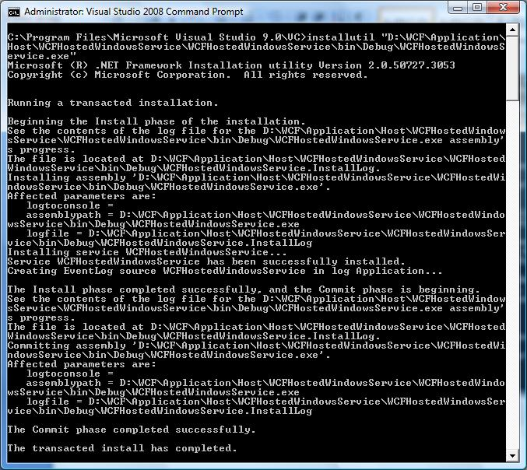

**Step 11:** Now service is Hosted sucessfully and we can create the proxy class for the service and start using in the client applcaiton.

# Binding

Binding will describes how client will communicate with service. There are different protocols available for the WCF to communicate to the Client. You can mention the protocol type based on your requirements.

Binding has several characteristics, including the following:

* **Transport**

Defines the base protocol to be used like HTTP, Named Pipes, TCP, and MSMQ are some type of protocols.

* **Encoding (Optional)**

Three types of encoding are available-Text, Binary, or Message Transmission Optimization Mechanism (MTOM). MTOM is an interoperable message format that allows the effective transmission of attachments or large messages (greater than 64K).

* **Protocol(Optional)**

Defines information to be used in the binding such as Security, transaction or reliable messaging capability

# Bindings and Channel Stacks

In WCF all the communication details are handled by channel, it is a stack of channel components that all messages pass through during runtime processing. The bottom-most component is the transport channel. This implements the given transport protocol and reads incoming messages off the wire. The transport channel uses a message encoder to read the incoming bytes into a logical Message object for further processing.

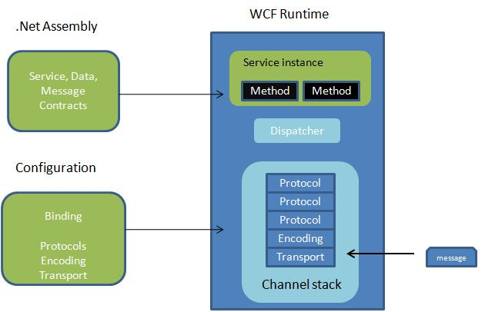

Figure 1: Bindings and Channel Stacks (draw new diagram)

After that, the message bubbles up through the rest of the channel stack, giving each protocol channel an opportunity to do its processing, until it eventually reaches the top and WCF dispatches the final message to your service implementation. Messages undergo significant transformation along the way.

It is very difficult for the developer to work directly with channel stack architecture. Because you have to be very careful while ordering the channel stack components, and whether or not they are compatible with one other.

So WCF provides easy way of achieving this using end point. In end point we will specify address, binding and contract. To know more about end point. Windows Communication Foundation follows the instructions outlined by the binding description to create each channel stack. The binding binds your service implementation to the wire through the channel stack in the middle.

# Types of Binding

Let us see more detailed on predefined binding

### BasicHttpBinding

* It is suitable for communicating with ASP.NET Web services (ASMX)-based services that comfort with WS-Basic Profile conformant Web services.
* This binding uses HTTP as the transport and text/XML as the default message encoding.
* Security is disabled by default
* This binding does not support WS-* functionalities like WS- Addressing, WS-Security, WS-ReliableMessaging
* It is fairly weak on interoperability.

### WSHttpBinding

* Defines a secure, reliable, interoperable binding suitable for non-duplex service contracts.
* It offers lot more functionality in the area of interoperability.
* It supports WS-* functionality and distributed transactions with reliable and secure sessions using SOAP security.
* It uses HTTP and HTTPS transport for communication.
* Reliable sessions are disabled by default.

### WSDualHttpBinding

This binding is same as that of WSHttpBinding, except it supports duplex service. Duplex service is a service which uses duplex message pattern, which allows service to communicate with client via callback.

In WSDualHttpBinding reliable sessions are enabled by default. It also supports communication via SOAP intermediaries.

### WSFederationHttpBinding

This binding support federated security. It helps implementing federation which is the ability to flow and share identities across multiple enterprises or trust domains for authentication and authorization. It supports WS-Federation protocol.

### NetTcpBinding

This binding provides secure and reliable binding environment for .Net to .Net cross machine communication. By default it creates communication stack using WS-ReliableMessaging protocol for reliability, TCP for message delivery and windows security for message and authentication at run time. It uses TCP protocol and provides support for security, transaction and reliability.

### NetNamedPipeBinding

This binding provides secure and reliable binding environment for on-machine cross process communication. It uses NamedPipe protocol and provides full support for SOAP security, transaction and reliability. By default it creates communication stack with WS-ReliableMessaging for reliability, transport security for transfer security, named pipes for message delivery and binary encoding.

### NetMsmqBinding

* This binding provides secure and reliable queued communication for cross-machine environment.
* Queuing is provided by using MSMQ as transport.
* It enables for disconnected operations, failure isolation and load leveling

### NetPeerTcpBinding

* This binding provides secure binding for peer-to-peer environment and network applications.
* It uses TCP protocol for communication
* It provides full support for SOAP security, transaction and reliability.

# Binding configuration

Binding can be configured either through configuration file or Programming. Let us see the binding representation in each method.

### Administrative (Configuration file):

In the configuration file of the hosting application, you can add the <bindings> element inside the <system.serviceModel> element and add the properties to particular binding type. Properties corresponding to the particular binding type can be mentioned below. Name of the binding properties that you are going to use has to be mention in the end point.

<system.serviceModel>

<services>

<service name="MyService">

<endpoint address="http://localhost/IISHostedService/MyService.svc"

binding="wsHttpBinding" bindingName="wshttpbind" contract="IMyService">

<identity>

<dns value="localhost"/>

</identity>

</endpoint>

<endpoint address="mex" binding="mexHttpBinding" contract="IMetadataExchange"/>

</service>

</services>

<bindings>

<wsHttpBinding>

<binding name="wshttpbind" allowCookies="true" closeTimeout="00:01:00"

receiveTimeout="00:01:00" />

</wsHttpBinding>

</bindings>

</system.serviceModel>

### Programming Model:

In the following code, I have created the *WSHttpBinding* object and assign the properties which to be configured. This binding object is added to the Service endpoint for client communication. Similarly you can also create any type of binding and add to endpoint.

//Create a URI to serve as the base address

Uri httpUrl = new Uri("http://localhost:8090/MyService/SimpleCalculator");

//Create ServiceHost

ServiceHost host =

new ServiceHost(typeof(MyCalculatorService.SimpleCalculator), httpUrl);

//Create Binding to add to end point

WSHttpBinding wshttpbind = new WSHttpBinding();

wshttpbind.AllowCookies = true;

wshttpbind.CloseTimeout = new TimeSpan(0, 1, 0);

wshttpbind.ReceiveTimeout = new TimeSpan(0, 1, 0);

//Add a service endpoint

host.AddServiceEndpoint

(typeof(MyCalculatorService.ISimpleCalculator), wshttpbind, "");

//Enable metadata exchange

ServiceMetadataBehavior smb = new ServiceMetadataBehavior();

smb.HttpGetEnabled = true;

host.Description.Behaviors.Add(smb);

//Start the Service

host.Open();

Console.WriteLine("Service is host at " + DateTime.Now.ToString());

Console.WriteLine("Host is running... Press key to stop");

Console.ReadLine();

**Note:** It is always good if you configure the binding properties using configuration file, because while moving to the production you no need to change in the code and recompile it. It is always good practice to represent in the configuration file.

# Metadata Exchange

WCF provides rich infrastructure for Exporting, Publishing, retrieving and Importing the metadata. WCF uses the Metadata to describe how to interact with the service endpoint. Using the metadata, client will create the proxy class for the service using *SvcUtil.exe*

### Exporting Service Metadata

It is the process of describing the service endpoint so that client can understand how to use the service.

### Publishing Service Metadata

It is the process publishing metadata. It involves converting CLR type and binding information into WSDL or some other low level representation.

### Retrieving Service Metadata

It is the process of retrieving the metadata. It uses WS-MetadataExcahge or HTTP protocol for retrieving the metadata. Importing Service Metadata - It is the process of generating the abstract representation of the service using metadata.

Now we are going to focus mainly on publishing metadata. There are two way to publish metadata, either we can use HTTP-GET or through message exchange endpoint. By default service metadata is turn-off due to security reason. WCF metadata infrastructure resides in *System.ServiceModel.Description* namespace. Service metadata can be used for following purpose

* Automatically generating the client for consuming service
* Implementing the service description
* Updating the binding for a client

Now let us understand the publishing the metadata using [HTTP-GET](http://www.wcftutorial.net/HTTP_GET-Enabled-Metadata.aspx) method.

# HTTP_GET Enabled Metadata

We will use ServiceBehaviour to publish the metadata using HTTP-GET. This can be configures either administratively or Programmatically. Http and Https can expose by appending "?wsdl" to the end of the service address. For example service address is *http://localhost:9090/MyCalulatorService* , HTTP-Get metadata address is given by *http://localhost:9090/MyCalulatorService?wsdl*.

### Administrative (Configuration file):

In the below mention configuration information, you can find the behavior section in the ServiceBehavior. You can expose the metadata using ServiceMetadata node with httpGetEnable='True'.

<system.serviceModel>

<services>

<service behaviorConfiguration="ServiceBehavior" name="MyService">

<endpoint address="http://localhost/IISHostedService/MyService.svc"

binding="wsHttpBinding" contract="IMyService">

<identity>

<dns value="localhost"/>

</identity>

</endpoint>

</service>

</services>

<behaviors>

<serviceBehaviors>

<behavior name="ServiceBehavior">

<!-Setting httpGetEnabled you can publish the metadata -->

<serviceMetadata httpGetEnabled="true"/>

</behavior>

</serviceBehaviors>

</behaviors>

</system.serviceModel>

### Progarmming Model:

Using ServiceMetadataBehavior you can enable the metadata exchange. In the following code, I have created the ServiceMetadataBehavior object and assigned HttpGetEnabled property to true. Then you have to add the behavior to host description as shown. This set of code will publish the metadata using HTTP-GET.

//Create a URI to serve as the base address

Uri httpUrl = new Uri("http://localhost:8090/MyService/SimpleCalculator");

//Create ServiceHost

ServiceHost host = new

ServiceHost(typeof(MyCalculatorService.SimpleCalculator), httpUrl);

//Add a service endpoint

host.AddServiceEndpoint

(typeof(MyCalculatorService.ISimpleCalculator), new WSHttpBinding(), "");

//Enable metadata exchange

ServiceMetadataBehavior smb = new ServiceMetadataBehavior();

//Enable metadata exchange using HTTP-GET

smb.HttpGetEnabled = true;

host.Description.Behaviors.Add(smb);

//Start the Service

host.Open();

Console.WriteLine("Service is host at " + DateTime.Now.ToString());

Console.WriteLine("Host is running... Press key to stop");

Console.ReadLine();

# Metadata Exchange Endpoint

Exposing the metadata using HTTP-GET has a disadvantage, such that there is no guarantee that other platforms you interact will support it. There is other way of exposing the using special endpoint is called as Metadata Exchange Endpoint. You can have as many metadata exchange endpoints as you want.

#### Address

It is basically Uri to identify the metadata. You can specify as address in the endpoint but append with "mex" keyword. For example "http://localhost:9090/MyCalulatorService/mex"

#### Binding

There are four types of bindings supported for metadata exchange. They are mexHttpBinding, mexHttpsBinding, mexNamedPipesBinding, mexTcpBinding.

#### Contract

IMetadataExchange is the contract used for MEX endpoint. WCF service host automatically provides the implementation for this IMetadataExcahnge while hosting the service.

You can create the Metadata Exchange Endpoint either Administrative (configuration file) or programmatically.

### Administrative (Configuration file):

In the configuration file of the hosting application, you can add metadata exchange endpoint as shown below.

<system.serviceModel>

<services>

<service name="MyService">

<endpoint address="http://localhost/IISHostedService/MyService.svc"

binding="wsHttpBinding" contract="IMyService">

<identity>

<dns value="localhost"/>

</identity>

</endpoint>

<endpoint address="mex" binding="mexHttpBinding" contract="IMetadataExchange"/>

</service>

</services>

</system.serviceModel>

### Programming Model:

In the following code I have mention about creating the Metadata Exchange Endpoint through coding. Steps to create the metadata endpoint are

* Create the *ServiceMetadataBehavior* object and add to Service host description.
* ServiceMetadataBehavior smb = new ServiceMetadataBehavior();

host.Description.Behaviors.Add(smb);

* Create the metadata binding object using *MetadataExchangeBinding*

Binding mexBinding = MetadataExchangeBindings.CreateMexHttpBinding ();

* 3. Add the endpoint to the service host with address, binding and contract.

host.AddServiceEndpoint(typeof(IMetadataExchange), mexBinding, "mex");

Complete code for hosting the service with metadata exchange endpoint is shown below.

//Create a URI to serve as the base address

Uri httpUrl = new Uri("http://localhost:8090/MyService/SimpleCalculator");

//Create ServiceHost

ServiceHost host = new

ServiceHost(typeof(MyCalculatorService.SimpleCalculator), httpUrl);

//Add a service endpoint

host.AddServiceEndpoint

(typeof(MyCalculatorService.ISimpleCalculator), new WSHttpBinding(), "");

//Enable metadata exchange

ServiceMetadataBehavior smb = new ServiceMetadataBehavior();

host.Description.Behaviors.Add(smb);

Binding mexBinding = MetadataExchangeBindings.CreateMexHttpBinding ();

//Adding metadata exchange endpoint

host.AddServiceEndpoint(typeof(IMetadataExchange), mexBinding, "mex");

//Start the Service

host.Open();

Console.WriteLine("Service is host at " + DateTime.Now.ToString());

Console.WriteLine("Host is running... Press key to stop");

Console.ReadLine();

# Contract

# Service Contract

Service contract describes the operation that service provide. A Service can have more than one service contract but it should have at least one Service contract.

Service Contract can be define using [ServiceContract] and [OperationContract] attribute. [ServiceContract] attribute is similar to the [WebServcie] attribute in the WebService and [OpeartionContract] is similar to the [WebMethod] in WebService.

* It describes the client-callable operations (functions) exposed by the service
* It maps the interface and methods of your service to a platform-independent description
* It describes message exchange patterns that the service can have with another party. Some service operations might be one-way; others might require a request-reply pattern
* It is analogous to the element in WSDL

To create a service contract you define an interface with related methods representative of a collection of service operations, and then decorate the interface with the *ServiceContract* Attribute to indicate it is a service contract. Methods in the interface that should be included in the service contract are decorated with the *OperationContract* Attribute.

[ServiceContract()]

public interface ISimpleCalculator

{

[OperationContract()]

int Add(int num1, int num2);

}

Once we define Service contract in the interface, we can create implement class for this interface.

public class SimpleCalculator : ISimpleCalculator

{

public int Add(int num1, int num2)

{

return num1 + num2;

}

}

With out creating the interface, we can also directly created the service by placing Contract in the implemented class. But it is not good practice of creating the service

[ServiceContract()]

public class SimpleCalculator

{

[OperationContract()]

public int Add(int num1, int num2)

{

return num1 + num2;

}

}

Now you have some fundamental idea on Service contract. Next we will look into Data Contract.

# Data Contract

A data contract is a formal agreement between a service and a client that abstractly describes the data to be exchanged.

Data contract can be explicit or implicit. Simple type such as int, string etc has an implicit data contract. User defined object are explicit or Complex type, for which you have to define a Data contract using [DataContract] and [DataMember] attribute.

A data contract can be defined as follows:

* It describes the external format of data passed to and from service operations
* It defines the structure and types of data exchanged in service messages
* It maps a CLR type to an XML Schema
* t defines how data types are serialized and deserialized. Through serialization, you convert an object into a sequence of bytes that can be transmitted over a network. Through deserialization, you reassemble an object from a sequence of bytes that you receive from a calling application.
* It is a versioning system that allows you to manage changes to structured data

We need to include *System.Runtime.Serialization* reference to the project. This assembly holds the *DataContract* and *DataMember* attribute.

Create user defined data type called Employee. This data type should be identified for serialization and deserialization by mentioning with [DataContract] and [DataMember] attribute.

[ServiceContract]

public interface IEmployeeService

{

[OperationContract]

Employee GetEmployeeDetails(int EmpId);

}

[DataContract]

public class Employee

{

private string m_Name;

private int m_Age;

private int m_Salary;

private string m_Designation;

private string m_Manager;

[DataMember]

public string Name

{

get { return m_Name; }

set { m_Name = value; }

}

[DataMember]

public int Age

{

get { return m_Age; }

set { m_Age = value; }

}

[DataMember]

public int Salary

{

get { return m_Salary; }

set { m_Salary = value; }

}

[DataMember]

public string Designation

{

get { return m_Designation; }

set { m_Designation = value; }

}

[DataMember]

public string Manager

{

get { return m_Manager; }

set { m_Manager = value; }

}

}

Implementation of the service class is shown below. In GetEmployee method we have created the Employee instance and return to the client. Since we have created the data contract for the Employee class, client will aware of this instance whenever he creates proxy for the service.

public class EmployeeService : IEmployeeService

{

public Employee GetEmployeeDetails(int empId)

{

Employee empDetail = new Employee();

//Do something to get employee details and assign to 'empDetail' properties

return empDetail;

}

}

### Client side

On client side we can create the proxy for the service and make use of it. The client side code is shown below.

protected void btnGetDetails_Click(object sender, EventArgs e)

{

EmployeeServiceClient objEmployeeClient = new EmployeeServiceClient();

Employee empDetails;

empDetails = objEmployeeClient.GetEmployeeDetails(empId);

//Do something on employee details

}

**Message Contract**

**Message**

Message is the packet of data which contains important information. WCF uses these messages to transfer information from Source to destination.

WCF uses SOAP(Simple Object Access Protocol) Message format for communication. SOAP message contain Envelope, Header and Body.SOAP envelope contails name, namespace,header and body element. SOAP Hear contain important information which are not directly related to message. SOAP body contains information which is used by the target.

Diagram Soap envelope

**Message Pattern**

It describes how the programs will exchange message each other. There are three way of communication between source and destination

1. **Simplex** - It is one way communication. Source will send message to target, but target will not respond to the message.
2. **Request/Replay** - It is two way communications, when source send message to the target, it will resend response message to the source. But at a time only one can send a message
3. **Duplex** - It is two way communication, both source and target can send and receive message simultaniouly.

**What is Message contract?**

As I said earlier, WCF uses SOAP message for communication. Most of the time developer will concentrate more on developing the DataContract, Serializing the data, etc. WCF will automatically take care of message. On Some critical issue, developer will also require control over the SOAP message format. In that case WCF provides Message Contract to customize the message as per requirement.

WCF supports either RPC(Remote Procedure Call) or Message style operation model. In the RPC model, you can develop operation with Ref and out parameter. WCF will automatically create the message for operation at run time. In Message style operation WCF allows to customize the message header and define the security for header and body of the message.

**Defining Message Contract**

Message contract can be applied to type using MessageContract attribute. Custom Header and Body can be included to message using 'MessageHeader' and '*MessageBodyMember*'atttribute. Let us see the sample message contract definition.

[MessageContract]

public class EmployeeDetails

{

[MessageHeader]

public string EmpID;

[MessageBodyMember]

public string Name;

[MessageBodyMember]

public string Designation;

[MessageBodyMember]

public int Salary;

[MessageBodyMember]

public string Location;

}

When I use this EmployeeDeatils type in the service operation as parameter. WCF will add extra header call 'EmpID' to the SOAP envelope. It also add Name, Designation, Salary, Location as extra member to the SOAP Body.

**Rules :**

You have to follow certain rules while working with Message contract

1. When using Message contract type as parameter, Only one parameter can be used in servicie Operation
2. [OperationContract]
3. void SaveEmployeeDetails(EmployeeDetails emp);
4. Service operation either should return Messagecontract type or it should not return any value
5. [OperationContract]
6. EmployeeDetails GetEmployeeDetails();
7. Service operation will accept and return only message contract type. Other data types are not allowed.
8. [OperationContract]
9. EmployeeDetails ModifyEmployeeDetails(EmployeeDetails emp);

**Note:** If a type has both Message and Data contract, service operation will accept only message contract.

# MessageHeaderArray Attribute

Consider the Message contract type definition as shown below.

[MessageContract]

public class Department

{

[MessageHeader]

public string DepartmentID;

[MessageHeader]

public string DepartmentName;

[MessageHeader]

public Employees Employee();

}

In this we are having array of Employee type as message header. When this converted to SOAP Header it looks as shown below.

<Department>

<DepartmentID>PRO1243</DepartmentID>

<DepartmentName>Production</DepartmentName>

<Employees>

<Employee>Sam</Employee>

<Employee>Ram</Employee>

<Employee>Raja</Employee>

</Employees>

</Department>

Suppose you want to show the all employee detail in same level. We can use MessageHeaderArray attribute which will serialize the array element independently. If you use the MessageHeaderArray attribute of Employees, SOAP message will look as shown below.

<Department>

<DepartmentID>PRO1243</DepartmentID>

<DepartmentName>Production</DepartmentName>

<Employee>Sam</Employee>

<Employee>Ram</Employee>

<Employee>Raja</Employee>

</Department>

**Note:** MessageHeaderArray Attribute is applicable only for Array, not for collection.

# Message Contract Properties

### ProtectionLevel

You can mention the *MessageHeader* or *MessageBodyMember* to be signed or Encrypted using *ProtectionLevel* property.

**Example**

using System.Net.Security;

[MessageContract]

public class EmployeeDetails

{

[MessageHeader(ProtectionLevel=ProtectionLevel.None)]

public string EmpID;

[MessageBodyMember(ProtectionLevel = ProtectionLevel.Sign )]

public string Name;

[MessageBodyMember(ProtectionLevel = ProtectionLevel.Sign )]

public string Designation;

[MessageBodyMember(ProtectionLevel=ProtectionLevel.EncryptAndSign)]

public int Salary;

}

In the above type definition, we have made the different protection level for body. But the protection level of the body is determind by the highest *ProtectionLevel* property. By default if you are not specifying the protection level it takes 'EncryptAndSign'. So it good if you specify minimum ProtectionLevel required.

### Name and Namespace:

SOAP representation of the message element can be change by mentioning Name and Namespace property of the Header and Body member. By default namespace is the same as the namespace of the service contract that the message is participating. In the below example, I have mention the Name property to the EmpID and Name.

[MessageContract]

public class EmployeeDetails

{

[MessageHeader(Name="ID")]

public string EmpID;

[MessageBodyMember(Name="EmployeeName")]

public string Name;

[MessageBodyMember()]

public string Designation;

[MessageBodyMember()]

public int Salary;

}

When SOAP message representation, its name is changed to ID and EmployeeName.

<EmployeeDetails>

<ID>45634</ID>

<EmployeeName>Sam</EmployeeName>

<Designation>Software Engineer</Designation>

<Salary>25000</Salary>

</EmployeeDetails>

### Order

The order of the body elements are alpehabetical by default. But you can control the order, usiing *Order* property in the *MessageBody* attribute.

[MessageContract]

public class EmployeeDetails

{

[MessageHeader()]

public string EmpID;

[MessageBodyMember(Order=2)]

public string Name;

[MessageBodyMember(Order=3)]

public string Designation;

[MessageBodyMember(Order=1)]

public int Salary;

}

# Fault Contract

Service that we develop might get error in some case. This error should be reported to the client in proper manner. Basically when we develop managed application or service, we will handle the exception using try- catch block. But these exceptions handlings are technology specific.

In order to support interoperability and client will also be interested only, what wents wrong? not on how and where cause the error.

By default when we throw any exception from service, it will not reach the client side. WCF provides the option to handle and convey the error message to client from service using SOAP Fault contract.

Suppose the service I consumed is not working in the client application. I want to know the real cause of the problem. How I can know the error? For this we are having Fault Contract. Fault Contract provides documented view for error accorded in the service to client. This help as to easy identity the what error has accord. Let us try to understand the concept using sample example.

**Step 1:** I have created simple calculator service with Add operation which will throw general exception as shown below

//Service interface

[ServiceContract()]

public interface ISimpleCalculator

{

[OperationContract()]

int Add(int num1, int num2);

}

//Service implementation

public class SimpleCalculator : ISimpleCalculator

{

public int Add(int num1, int num2)

{

//Do something

throw new Exception("Error while adding number");

}

}

**Step 2:** On client side code. Exceptions are handled using try-Catch block. Even though I have capture the exception when I run the application. I got the message that exceptions are not handled properly.

try

{

MyCalculatorServiceProxy.MyCalculatorServiceProxy proxy

= new MyCalculatorServiceProxy.MyCalculatorServiceProxy();

Console.WriteLine("Client is running at " + DateTime.Now.ToString());

Console.WriteLine("Sum of two numbers... 5+5 =" + proxy.Add(5, 5));

Console.ReadLine();

}

catch (Exception ex)

{

Console.WriteLine(ex.Message);

Console.ReadLine();

}

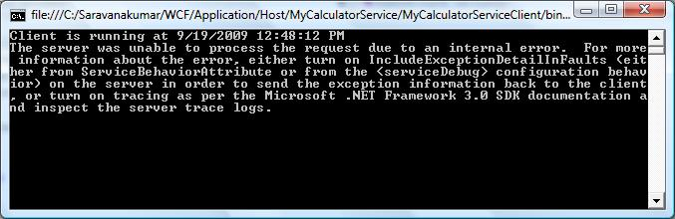

**Step 3:** Now if you want to send exception information form service to client, you have to use FaultException as shown below.

public int Add(int num1, int num2)

{

//Do something

throw new FaultException("Error while adding number");

}

**Step 4:** Output window on the client side is show below.

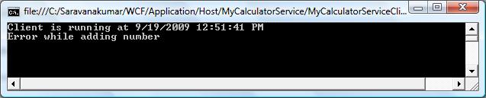

**Step 5:** You can also create your own Custom type and send the error information to the client using *FaultContract*. These are the steps to be followed to create the fault contract.

* Define a type using the data contract and specify the fields you want to return.
* Decorate the service operation with the FaultContract attribute and specify the type name.
* Raise the exception from the service by creating an instance and assigning properties of the custom exception.

**Step 6:** Defining the type using Data Contract

[DataContract()]

public class CustomException

{

[DataMember()]

public string Title;

[DataMember()]

public string ExceptionMessage;

[DataMember()]

public string InnerException;

[DataMember()]

public string StackTrace;

}

**Step 7:** Decorate the service operation with the *FaultContract*

[ServiceContract()]

public interface ISimpleCalculator

{

[OperationContract()]

[FaultContract(typeof(CustomException))]

int Add(int num1, int num2);

}

**Step 8:** Raise the exception from the service

public int Add(int num1, int num2)

{

//Do something

CustomException ex = new CustomException();

ex.Title = "Error Funtion:Add()";

ex.ExceptionMessage = "Error occur while doing add function.";

ex.InnerException = "Inner exception message from serice";

ex.StackTrace = "Stack Trace message from service.";

throw new FaultException(ex,"Reason: Testing the Fault contract") ;

}

**Step 9:** On client side, you can capture the service exception and process the information, as shown below.

try

{

MyCalculatorServiceProxy.MyCalculatorServiceProxy proxy

= new MyCalculatorServiceProxy.MyCalculatorServiceProxy();

Console.WriteLine("Client is running at " + DateTime.Now.ToString());

Console.WriteLine("Sum of two numbers... 5+5 =" + proxy.Add(5, 5));

Console.ReadLine();

}

catch (FaultException<MyCalculatorService.CustomException> ex)

{

//Process the Exception

}

# Instance Management

Instance management refers to the way a service handles a request from a client. Instance management is set of techniques WCF uses to bind client request to service instance, governing which service instance handles which client request. It is necessary because application will differ in their need for scalability, performance, durability, transaction and queued calls.

Basically there are three instance modes in WCF:

* [Per-Call instance mode](http://www.wcftutorial.net/Per-Call-Service.aspx)
* [Per-Session instance mode](http://www.wcftutorial.net/Per-Session-Service.aspx)
* [Singleton Instance Mode](http://www.wcftutorial.net/Singleton-Service.aspx)

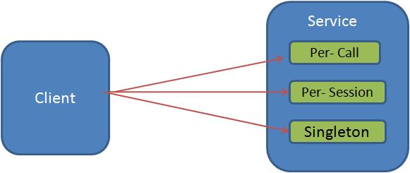

### Configuration:

Instance mode can be configured using *ServiceBehavior* attribute. This can be specified at implementing the service contract as shown below.

[ServiceContract()]

public interface IMyService

{

[OperationContract]

int MyMethod();

}

[ServiceBehavior(InstanceContextMode=InstanceContextMode.Single)]

public class MyService:IMyService

{

public int MyMethod()

{

//Do something

}

}

# Per-Call Service

When WCF service is configured for Per-Call instance mode, Service instance will be created for each client request. This Service instance will be disposed after response is sent back to client.

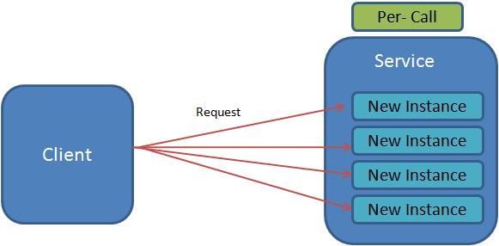

Following diagram represent the process of handling the request from client using Per-Call instance mode.

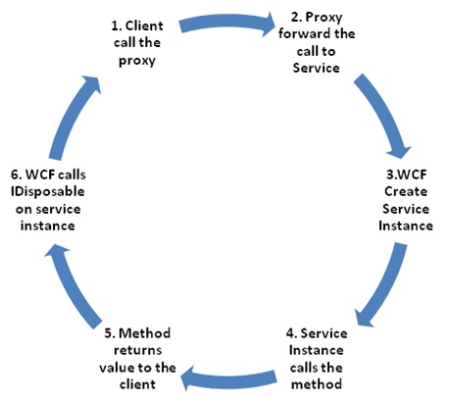

Let as understand the per-call instance mode using example.

**Step 1:** Create the service contract called IMyService and implement the interface. Add service behavior attribute to the service class and set the *InstanceContextMode* property to *PerCall* as show below.

[ServiceContract()]

public interface IMyService

{

[OperationContract]

int MyMethod();

}

**Step 2:** In this implementation of MyMethod operation, increment the static variable(m_Counter). Each time while making call to the service, m_Counter variable is incremented and return the value to the client.

[ServiceBehavior(InstanceContextMode=InstanceContextMode.PerCall)]

public class MyService:IMyService

{

static int m_Counter = 0;

public int MyMethod()

{

m_Counter++;

return m_Counter;

}

}

**Step 3:** Client side, create the proxy for the service and call "myMethod" operation multiple time.

static void Main(string[] args)

{

Console.WriteLine("Service Instance mode: Per-Call");

Console.WriteLine("Client making call to service...");

//Creating the proxy on client side

MyCalculatorServiceProxy.MyServiceProxy proxy =

new MyCalculatorServiceProxy.MyServiceProxy();

Console.WriteLine("Counter: " + proxy.MyMethod());

Console.WriteLine("Counter: " + proxy.MyMethod());

Console.WriteLine("Counter: " + proxy.MyMethod());

Console.WriteLine("Counter: " + proxy.MyMethod());

Console.ReadLine();

}

Surprisingly, all requests to service return '1', because we configured the Instance mode to Per-Call. Service instance will created for each request and value of static variable will be set to one. While return back, service instance will be disposed. Output is shown below.

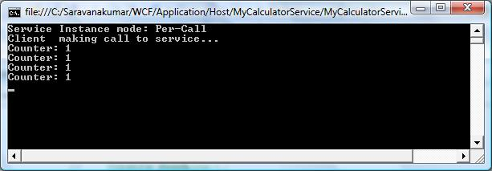

Fig: PercallOutput

# Per-Session Service

When WCF service is configured for Per-Session instance mode, logical session between client and service will be maintained. When the client creates new proxy to particular service instance, a dedicated service instance will be provided to the client. It is independent of all other instance.

Following diagram represent the process of handling the request from client using Per-Session instance mode.

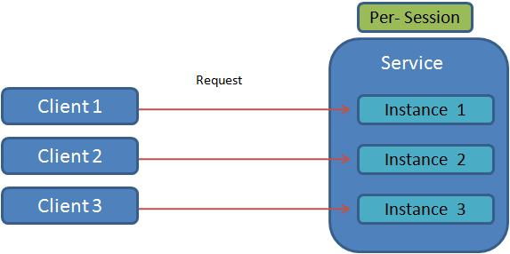

Let as understand the Per-Session instance mode using example.

**Step 1:** Create the service contract called IMyService and implement the interface. Add service behavior attribute to the service class and set the *InstanceContextMode* property to *PerSession* as show below.

[ServiceContract()]

public interface IMyService

{

[OperationContract]

int MyMethod();

}

**Step 2:** In this implementation of MyMethod operation, increment the static variable (m_Counter). Each time while making call to the service, m_Counter variable will be incremented and return the value to the client.

[ServiceBehavior(InstanceContextMode=InstanceContextMode.PerSession)]

public class MyService:IMyService

{

static int m_Counter = 0;

public int MyMethod()

{

m_Counter++;

return m_Counter;

}

}

**Step 3:** Client side, create the proxy for the service and call "myMethod" operation multiple time.

static void Main(string[] args)

{

Console.WriteLine("Service Instance mode: Per-Session");

Console.WriteLine("Client making call to service...");

//Creating the proxy on client side

MyCalculatorServiceProxy.MyServiceProxy proxy =

new MyCalculatorServiceProxy.MyServiceProxy();

Console.WriteLine("Counter: " + proxy.MyMethod());

Console.WriteLine("Counter: " + proxy.MyMethod());

Console.WriteLine("Counter: " + proxy.MyMethod());

Console.WriteLine("Counter: " + proxy.MyMethod());

Console.ReadLine();

}

All request to service return incremented value (1, 2, 3, 4), because we configured the instance mode to Per-Session. Service instance will be created once the proxy is created at client side. So each time request is made to the service, static variable is incremented. So each call to MyMethod return incremented value. Output is shown below.

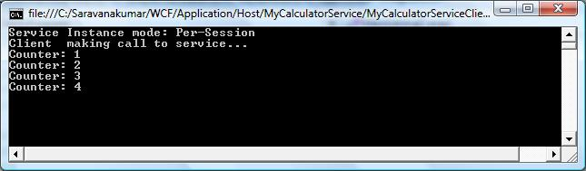

Fig: PersessionOutput.

# Singleton Service

When WCF service is configured for Singleton instance mode, all clients are independently connected to the same single instance. This singleton instance will be created when service is hosted and, it is disposed when host shuts down.

Following diagram represent the process of handling the request from client using Singleton instance mode.

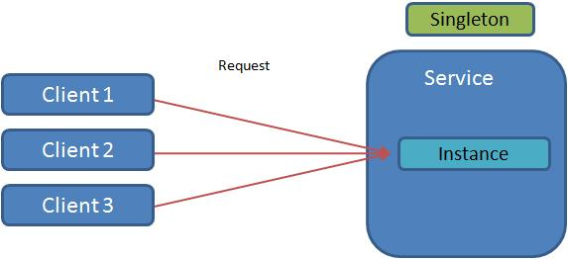

Let as understand the Singleton Instance mode using example.

**Step 1:** Create the service contract called IMyService and implement the interface. Add service behavior attribute to the service class and set the *InstanceContextMode* property to *Single* as show below.

[ServiceContract()]

public interface IMyService

{

[OperationContract]

int MyMethod();

}

**Step 2:** In this implementation of MyMethod operation, increment the static variable(m_Counter). Each time while making call to the service, m_Counter variable is incremented and return the value to the client

[ServiceBehavior(InstanceContextMode=InstanceContextMode.Single)]

public class MyService:IMyService

{

static int m_Counter = 0;

public int MyMethod()

{

m_Counter++;

return m_Counter;

}

}

**Step 3:** Client side, create the two proxies for the service and made a multiple call to MyMethod.

static void Main(string[] args)

{

Console.WriteLine("Service Instance mode: Singleton");

Console.WriteLine("Client 1 making call to service...");

//Creating the proxy on client side

MyCalculatorServiceProxy.MyServiceProxy proxy =

new MyCalculatorServiceProxy.MyServiceProxy();

Console.WriteLine("Counter: " + proxy.MyMethod());

Console.WriteLine("Counter: " + proxy.MyMethod());

Console.WriteLine("Counter: " + proxy.MyMethod());

Console.WriteLine("Client 2 making call to service...");

//Creating new proxy to act as new client

MyCalculatorServiceProxy.MyServiceProxy proxy2 =

new MyCalculatorServiceProxy.MyServiceProxy();

Console.WriteLine("Counter: " + proxy2.MyMethod());

Console.WriteLine("Counter: " + proxy2.MyMethod());

Console.ReadLine();

}

When two proxy class made a request to service, single instance at service will handle it and it return incremented value (1, 2, 3, 4), because instance mode is configured to 'Single'. Service instance is created when it is hosted. So this instance will remain till host is shutdown. Output is shown below.

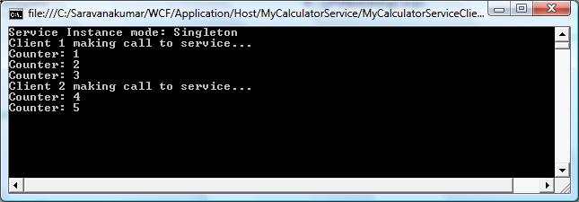

Fig: SingletonOutput.

# Instance Deactivation

In Instance Management System tutorial, you learn how to create sessionful service instance. Basically service instance is hosted in a context. Session actually correlated the client message not to the instance, but to the context that host it. When session starts, context is created and when it closes, context is terminated. WCF provides the option of separating the two lifetimes and deactivating the instance separately from its context.

*ReleaseInstanceMode* property of the *OberationalBehavior* attribute used to control the instance in relation to the method call.

Followings are the list Release mode available in the *ReleaseInstanceMode*

1. RealeaseInstanceMode.None
2. RealeaseInstanceMode.BeforeCall
3. RealeaseInstanceMode.AfterCall
4. RealeaseInstanceMode.BeforeAndAfterCall

Below code show, how to add the 'ReleaseInstanceMode' property to the operational behavior.

[ServiceContract()]

public interface ISimpleCalculator

{

[OperationContract()]

int Add(int num1, int num2);

}

[OperationBehavior(ReleaseInstanceMode=ReleaseInstanceMode.BeforeCall]

public int Add(int num1, int num2)

{

return num1 + num2;

}

### ReleaseInstanceMode.None

This property means that it will not affect the instance lifetime. By default ReleaseInstanceMode property is set to 'None'.

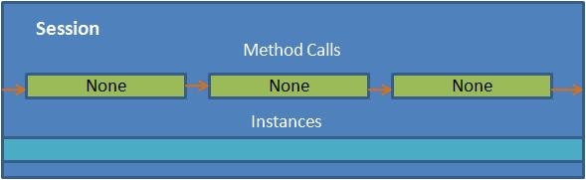

### ReleaseInstanceMode.BeforeCall

This property means that it will create new instance before a call is made to the operation.

If the instance is already exist,WCF deactivates the instance and calls Dispose() before the call is done. This is designed to optimize a method such as Create()

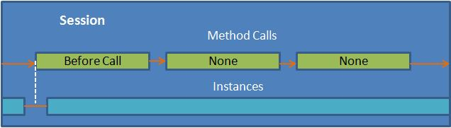

### ReleaseInstanceMode.AfterCall

This property means that it will deactivate the instance after call is made to the method.

This is designed to optimize a method such a Cleanup()

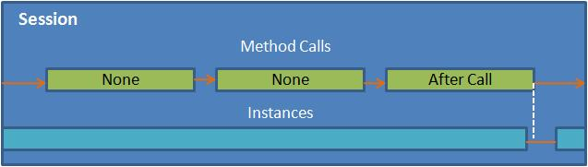

### ReleaseInstanceMode.BeforeAndAfterCall

This is means that it will create new instance of object before a call and deactivates the instance after call. This has combined effect of using *ReleaseInstanceMode.BeforeCall* and *ReleaseInstanceMode.AfterCall*

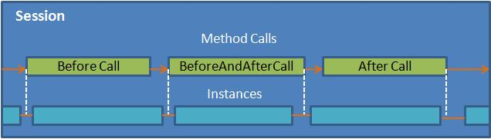

### Explicit Deactivate

You can also explicitly deactivate instance using *InstanceContext* object as shown below.

[ServiceContract()]

public interface IMyService

{

[OperationContract]

void MyMethod();

}

[ServiceBehavior(InstanceContextMode=InstanceContextMode.Single)]

public class MyService:IMyService

{

public void MyMethod()

{

//Do something

OperationContext.Current.InstanceContext.ReleaseServiceInstance();

}

}

# Durable Service

Durable services are WCF services that persist service state information even after service host is restarted or Client. It means that durable services have the capability to restore their own state when they are recycled. It can use data store like SQL database for maintain instance state. It is new feature in .Net 3.5

You might think that we can also maintain session using WCF sessions, but content in the session environment is not persisted by default. If the service is shut down or client closes the proxy, data will be lost. But in case of Durable service it is still maintained.

### Working:

When Durable service is created with database as data store, it will maintain all its state information in the table.

When a client make a request to the service, instance of the service is serialized, a new GUID is generated. This serialized instance xml and key will be saved in the database. We will call this GUID as instanceID. Service will send the instanceID to the client, so later it can use this id to get the instance state back. Even when client is shut down, instanceId will be saved at the client side. So when ever client opening the proxy, it can get back the previous state.

### Defining the Durable Service

Durable service can be implemented using [DurableService()] attribute. It takes 'CanCreateInstance' and 'CompletesInstance' property to mention on which operation instance state has to be saved and destroyed.

* **CanCreateInstance = true:** Calling this operation results in creating the serialization and inserting it into the datastore.
* **CompletesInstance = true:** Calling this operation results in deleting the persisted instance from the datastore.

[Serializable]

[DurableService()]

public class MyService :IMyservice

{

[DurableOperation(CanCreateInstance = true)]

public int StartPersistance()

{

//Do Something

}

[DurableOperation(CompletesInstance = true)]

public void EndPersistence()

{

//Do Something

}

}

# Throttling

WCF throttling provides some properties that you can use to limit how many instances or sessions are created at the application level. Performance of the WCF service can be improved by creating proper instance.

|  |  |
| --- | --- |
| **Attribute** | **Description** |
| maxConcurrentCalls | Limits the total number of calls that can currently be in progress across all service instances. The default is 16. |
| maxConcurrentInstances | The number of InstanceContext objects that execute at one time across a ServiceHost. The default is Int32.MaxValue. |
| maxConcurrentSessions | A positive integer that limits the number of sessions a ServiceHost object can accept. The default is 10. |

Service Throttling can be configured either Adminstractive or Programatically

### Administrative(configuration file)

Using <serviceThrottling> tag of the Service Behavior, you can configure the *maxConcurrentCalls*, *maxConcurrentInstances* , *maxConcurrentSessions* property as shown below.

<system.serviceModel>

<services >

<service behaviorConfiguration="ServiceBehavior" name="MyService">

<endpoint address="" binding="wsHttpBinding" contract="IMyService">

<identity>

<dns value="localhost"/>

</identity>

</endpoint>

<endpoint address="mex" binding="mexHttpBinding" contract="IMetadataExchange"/>

</service>

</services>

<behaviors>

<serviceBehaviors>

<behavior name="ServiceBehavior">

<serviceMetadata httpGetEnabled="true"/>

<serviceDebug includeExceptionDetailInFaults="true "/>

<serviceThrottling maxConcurrentCalls="500"

maxConcurrentInstances ="100"

maxConcurrentSessions ="200"/>

</behavior>

</serviceBehaviors>

</behaviors>

</system.serviceModel>

### Programming Model

Use ServiceThrottlingBehavior object to set concurrent calls, session and instance property.

ServiceHost host = new ServiceHost(typeof(MyService));

ServiceThrottlingBehavior throttle

= host.Description.Behaviors.Find();

if (throttle == null)

{

throttle = new ServiceThrottlingBehavior();

throttle.MaxConcurrentCalls = 500;

throttle.MaxConcurrentSessions = 200;

throttle.MaxConcurrentInstances = 100;

host.Description.Behaviors.Add(throttle);

}

host.Open();

# Transaction Propagation

In WCF, transaction can be propagated across service boundary. This enables service to participate in a client transaction and it includes multiple services in same transaction, Client itself will act as service or client.

We can specify whether or not client transaction is propagated to service by changing Binding and operational contract configuration

<bindings>

<netTcpBinding>

<binding transactionFlow="true"></binding>

</netTcpBinding>

</bindings>

Even after enabling transaction flow does not mean that the service wants to use the clientâ€™s transaction in every operation. We need to specify the â€œTransactionFlowAttributeâ€ in operational contract to enable transaction flow.

[ServiceContract]

public interface IService

{

[OperationContract]

[TransactionFlow(TransactionFlowOption.Allowed)]

int Add(int a, int b);

[OperationContract]

int Subtract(int a, int b);

}

**Note:** TransactionFlow can be enabled only at the operation level not at the service level.

|  |  |  |
| --- | --- | --- |
| **TransactionFlowOption** | **Binding configuration** |  |
| NotAllowed | transactionFlow="true"  or transactionFlow="false" | Client cannot propagate its transaction to service even client has transaction |
| Allowed | transactionFlow="true" | Service will allow to flow client transaction. It is not necessary that service to use client transaction. |
| Allowed | transactionFlow="false" | If service disallows at binding level, client also should disable at binding level else error will be occurred. |
| Mandatory | transactionFlow="true" | Both Service and client must use transaction aware binding |
| Mandatory | transactionFlow="false" | InvalidOperationException will be throw when service binding disables at binding level.  FaultException will be thrown when client disable at its binding level. |

# Transaction Protocols

As a developer we no need to concern about transaction protocols and transaction manager used by WCF. WCF itself will take care of what kind of transaction protocols should be used for different situation. Basically there are three different kinds of transaction protocols used by WCF.

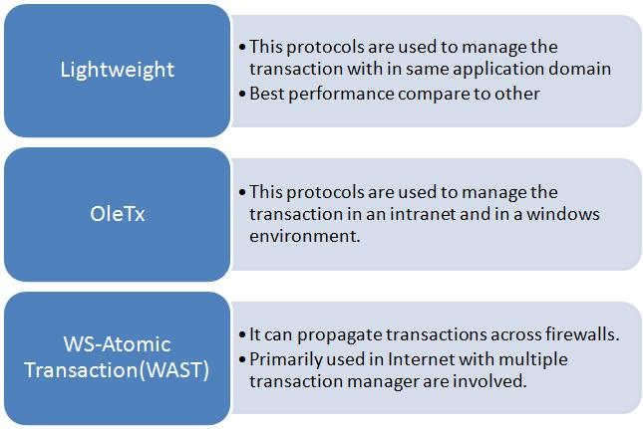

# Transaction Mode

This article explains about the how to configure the service and client transaction mode in WCF service.

* *Client transaction* – Transaction setting propagated or initiated from the client side
* *Server transaction* – Transaction setting propagated or initiated from server side

#### Client/Server transaction mode:

This setting ensures that service uses the client’s transaction if possible or a server side transaction when the client does not have a transaction.

1. Enable the *TransactionFlow=true* in binding configuration
2. Set *TransactionFlowOption.Allowed* in the operation contract
3. Set *TransactionScopeRequired=true* in the operation contract

#### Client transaction mode:

This settings ensures the service uses only the client’s transaction

1. Enable the *TransactionFlow=true* in binding configuration
2. Set *TransactionFlowOption.Mandatory* in the operation contract
3. Set *TransactionScopeRequired=true* in the operation contract

#### Service transaction mode:

This seeing ensures that the service always has a transaction, separated from any transaction its client may or may not have.

1. Disable the *TransactionFlow=false* in binding configuration
2. Set *TransactionFlowOption.NotAllowed* in the operation contract
3. Set *TransactionScopeRequired=true* in the operation contract

#### None transaction mode:

This setting ensures service does not use transaction

1. Disable the *TransactionFlow=false* in binding configuration
2. Set *TransactionFlowOption.NotAllowed* in the operation contract
3. Set *TransactionScopeRequired=false* in the operation contract

Below table explains about the Transaction mode activation based on the binging, contract and behavior settings

|  |  |  |  |
| --- | --- | --- | --- |
| **Binding Transaction flow** | **TransactionFlowOption** | **TransactionScopeRequired** | **Transaction mode** |
| False | Allowed | False | None |
| False | Allowed | True | Service |
| False | NotAllowed | False | None |
| False | Allowed | True | Service |
| True | Allowed | False | None |
| True | Allowed | True | Client/Service |
| True | Mandatory | False | None |
| True | Mandatory | True | Client |

# How to Create WCF Transaction

### Download:

[WCF_Transaction.zip](http://www.wcftutorial.net/Attachments/WCF_Transaction.zip)

This article explains about the how to create a WCF service with transaction enabled. Refer [“Transaction Mode”](http://www.wcftutorial.net/Transaction-Mode.aspx) article to learn more about the server side and client side transaction mode.

WCF transaction was explained with below employee service

1. Create the Employee WCF service to allow client user to insert employee detail
2. Enable the transaction from server side by setting proper attributes
3. Create the client application by consuming the Employee Service and insert the employee details
4. Run the client application to successfully insert the employee detail
5. Modify the service application to throw exception explicitly after successfully insert statement execution and check the transaction behavior.

**Step 1:**Create the Employee service that allows the addition of new employee details in DB. Decorate the operation contract with *TransactionFlow* attribute for enabling the transaction. TransactionFlowOption take three set of values.

* TransactionFlowOption.Allowed
* TransactionFlowOption.Mandatory
* TransactionFlowOption.NotAllowed

[ServiceContract]

public interface IService

{

[OperationContract]

[TransactionFlow(TransactionFlowOption.Allowed )]

bool AddEmployee(int id, string name, int salary);

}

**Step 2:**Create the service class which implements the service contract and set the operation behavior with TransactionScopeRequired = true . This attribute is used to enable the service transaction when the client transaction is not available.

public class Service : IService

{

[OperationBehavior(TransactionScopeRequired = true)]

public bool AddEmployee(int id, string name, int salary)

{

try

{

//Insert the employee tables inside the transaction

SqlConnection conn = new SqlConnection(@"Data Source=.\eaudit;Initial

Catalog=Test01;Integrated Security=SSPI;");

SqlCommand cmd = new SqlCommand("INSERT INTO [Test01].[dbo].[Employee]

VALUES("+id.ToString ()+",'"+name +"',

"+salary.ToString ()+")", conn);

cmd.CommandType = System.Data.CommandType.Text;

conn.Open();

cmd.ExecuteNonQuery();

conn.Close();

return true;

}

catch(Exception ex)

{

//return false ;

throw new FaultException(ex.Message);

}

}

}

**Step 3:**Update the service endpoint to enable transactions for wsHttpBinding by setting the transactionFlow attribute to true. Setting transactionFlow at config level doesn’t mean that the service wants to use the client’s transaction in every operation. It is required to set the transaction at the service contract level as mention in Step 1.

<system.serviceModel>

<behaviors>

<serviceBehaviors>

<behavior>

<serviceMetadata httpGetEnabled="true"/>

<serviceDebug includeExceptionDetailInFaults="true"/>

</behavior>

</serviceBehaviors>

</behaviors>

<serviceHostingEnvironment multipleSiteBindingsEnabled="true"/>

<services>

<service name="Service">

<endpoint address="" binding="wsHttpBinding"

contract="IService" bindingConfiguration="myTransactionBinding"/>

</service>

</services>

<bindings>

<wsHttpBinding>

<binding name="myTransactionBinding" transactionFlow="true" ></binding>

</wsHttpBinding>

</bindings>

</system.serviceModel>

**Step 4:**Now service creation is completed and let’s starts with the client application. Create a new console application from add Employee service as ServiceReference

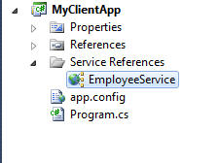

**Step 5:**Create a new proxy object for the employee service and call the AddEmployee method.

static void Main(string[] args)

{

bool result=false ;

using (TransactionScope ts = new TransactionScope

(TransactionScopeOption.RequiresNew))

{

try

{

EmployeeService.ServiceClient service =

new EmployeeService.ServiceClient();

result = service.AddEmployee(1, "raj", 3000);

ts.Complete();

}

catch (Exception ex)

{

ts.Dispose();

Console.WriteLine(ex.Message);

}

}

if( result == true )

Console.WriteLine("Employee details add successfully");

else

Console.WriteLine ("Error while adding employee details");

Console.ReadLine();

}

**Output:**

Output shows the employee detail is added successfully and DB also shows the new entry is made

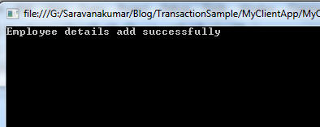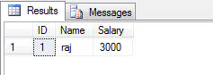

**Step 6:**Now everything works fine, let’s test the transaction by throwing the exception from server side after successful execution of employee details insert statement

try

{

//Insert the employee tables inside the transaction

SqlConnection conn = new SqlConnection(@"Data Source=.\eaudit;

Initial Catalog=Test01;Integrated Security=SSPI;");

SqlCommand cmd = new SqlCommand("INSERT INTO [Test01].[dbo].[Employee]

VALUES("+id.ToString ()+",'"+name +"',"+salary.ToString ()+")", conn);

cmd.CommandType = System.Data.CommandType.Text;

conn.Open();

cmd.ExecuteNonQuery();

conn.Close();

//Throw Exception after successful insert statement execution

throw new Exception("Sample exeception for testing");

return true;

}

catch(Exception ex)

{

//return false ;

throw new FaultException(ex.Message);

}

**Step 7:**Run the client application and check the output. Result clearly says that even insert statement is executed successfully and error is thrown after insert statement, DB is not updated. Because all the code execution is comes under the transaction so failure in any module of code will revert back all code execution.

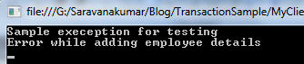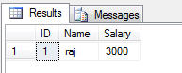

# Introduction to RESTful service

**REST – Representational State Transfer**

"REST, an architectural style for building distributed hypermedia driven applications, involves building Resource-Oriented Architecture (ROA) by defining resources that implement uniform interfaces using standard HTTP verbs (GET, POST, PUT, and DELETE), and that can be located/identified by a Uniform Resource Identifier (URI)."

Any Service which follows this REST architecture style is called as RESTful service. It became very popular because of it behavior, it is similar to the website i.e we can load the server information using web url in the browser. similarly we can also access/modify the server resource using Url in RESTful service

* RESTful service will allow the client (written in different language)to access or modify the resource in the server using URL.
* RESTful service uses the http protocol for its communication and it is stateless
* RESTful service can transfer the data in XML,JSON,RSS,ATOM

|  |  |  |
| --- | --- | --- |
| **SOAP** | **POX(plain-old XML)** | **REST** |
| * Simple Object Application Protocol * SOAP – is a package contain message information and it will be delivered by HTTP * Developers are mainly preferred to user because of its increase interoperability * Lot of tools are available in the market to generate the clients code from WSDL | * Plain raw XML message will be used for communication * Developers using POX had to write their own code for XML and HTTP for request/response message. * So most of the developers moved back to SOAP | * REST defines more of a transport-specific model * In reality HTTP is the only protocol that is used in practice today for building RESTful architecture. |

This basic REST design principle establishes a one-to-one mapping between create, read, update, and delete (CRUD) operations and HTTP methods. According to this mapping

* To create a resource on the server, use POST.
* To retrieve a resource, use GET.
* To change the state of a resource or to update it, use PUT.
* To remove or delete a resource, use DELETE.

RESTful service can be created by using WebGetAttribute and WebInvokeAttribute attribute. RESTful service has provided separate attribute for GET operation (WebGet) because it want to make use of complete features. Other operations like POST,PUT,DELETE will come under the WebInvoke attribute.

1. [How to create RESTful Service](http://www.wcftutorial.net/How_to_create_RESTful_Service.aspx)
2. [JSON using WCF service](http://www.wcftutorial.net/How_To_JSON_Using_WCF.aspx)

# How to create RESTful service

### Download Souce:

[MyFirstRESTfulService.zip](http://www.wcftutorial.net/Attachments/MyFirstRESTfulService.zip)

This sample explains about the creating the RESTful service to create and updating the resource information available at the sever side. This Restful service will be consumed using client console application.

**Step 1:** For our example we are suing “EmployeeData” class as Data Access Layer for storing and reading the employee information.

**Data Model class:**

namespace MyFirstRESTfulService

{

[DataContract]

public class Employee

{

[DataMember]

public int EmpId { get; set; }

[DataMember]

public string Fname { get; set; }

[DataMember]

public string Lname { get; set; }

[DataMember ]

public DateTime JoinDate { get; set; }

[DataMember]

public int Age { get; set; }

[DataMember]

public int Salary { get; set; }

[DataMember]

public string Designation { get; set; }

}

public partial class EmployeeData

{

private static readonly EmployeeData _instance = new EmployeeData();

private EmployeeData() { }

public static EmployeeData Instance

{

get

{

return _instance;

}

}

private List< Employee> empList = new List < Employee>()

{

new Employee() { EmpId = 1, Fname = "Sam", Lname = "kumar", JoinDate=new DateTime(2010,7, 21), Age=30,Salary=10000,Designation="Software Engineer"},

new Employee() { EmpId = 2, Fname = "Ram", Lname = "kumar", JoinDate=new DateTime(2009,6,8), Age=35,Salary=10000,Designation="Senior Software Engineer"},

new Employee() { EmpId = 3, Fname = "Sasi", Lname = "M", JoinDate=new DateTime(2008,3,5), Age=39,Salary=10000,Designation="Projet Manager"},

new Employee() { EmpId = 4, Fname = "Praveen", Lname = "KR", JoinDate=new DateTime(2010, 5,1), Age=56,Salary=10000,Designation="Projet Manager"},

new Employee() { EmpId = 5, Fname = "Sathish", Lname = "V", JoinDate = new DateTime(2006,12,15), Age=72,Salary=10000,Designation="Senior Software Engineer"},

new Employee() { EmpId = 6, Fname = "Rosh", Lname = "A", JoinDate=new DateTime(2009,2,2), Age=25,Salary=10000,Designation="Software Engineer"}

};

public List< Employee> EmployeeList

{

get

{

return empList;

}

}

public void Update(Employee updEmployee)

{

Employee existing = empList.Find(p => p.EmpId == updEmployee.EmpId);

if (existing == null)

throw new KeyNotFoundException("Specified Employee cannot be found");

existing.Fname = updEmployee.Fname;

existing.Lname = updEmployee.Lname;

existing.Age = updEmployee.Age;

}

public void Delete(int empid)

{

Employee existing = empList.Find(p => p.EmpId == empid);

empList.Remove(existing);

}

public void Add(Employee newEmployee)

{

empList.Add(new Employee

{

EmpId = newEmployee.EmpId,

Fname = newEmployee.Fname,

Lname = newEmployee.Lname,

Age = newEmployee.Age,

JoinDate = DateTime.Now,

Designation = newEmployee.Designation,

Salary = newEmployee.Salary

});

}

}

}

**Step 2:** Let’s start create EmployeeService (simple WCF) with ServiceContract, OperationContract and DataContract as shown below.

**Interface and Implementation:**

[ServiceContract()]

public interface IEmployeeService

{

[OperationContract]

List< Employee > GetAllEmployeeDetails();

[OperationContract]

Employee GetEmployee(int Id);

[OperationContract]

void AddEmployee(Employee newEmp);

[OperationContract]

void UpdateEmployee(Employee newEmp);

[OperationContract]

void DeleteEmployee(string empId);

}

[AspNetCompatibilityRequirements(RequirementsMode= AspNetCompatibilityRequirementsMode.Allowed )]

public class EmployeeService: IEmployeeService

{

public List < Employee > GetAllEmployeeDetails()

{

return EmployeeData.Instance.EmployeeList;

}

public Employee GetEmployee(int id)

{

IEnumerable< Employee > empList = EmployeeData.Instance.EmployeeList.Where(x => x.EmpId == id);

if (empList != null)

return empList.First< Employee >();

else

return null;

}

public void AddEmployee(Employee newEmp)

{

EmployeeData.Instance.Add(newEmp);

}

public void UpdateEmployee( Employee newEmp)

{

EmployeeData.Instance.Update(newEmp);

}

public void DeleteEmployee(string empId)

{

EmployeeData.Instance.Delete(System.Convert .ToInt32 (empId));

}

}

**Step2:** This service can be hosted as normal WCF service by creating the ServiceHost object and adding endpoint with different binding. This is already explained in [“ConsoledHosted WCF Service”](http://www.wcftutorial.net/WCF-Self-Hosting.aspx).

As it is mention in introduction section of RESTful service, all the resource located in server side can be accessed using url. Method exposed at the server side can be call using url, to do that we need to decorate the service method with “WebGet” or “WebInvoke” attribute as mention below

[ServiceContract()]

public interface IEmployeeService

{

[WebGet(UriTemplate = "Employee")]

[OperationContract]

List< Employee > GetAllEmployeeDetails();

[WebGet(UriTemplate = "Employee?id={id}")]

[OperationContract]

Employee GetEmployee(int Id);

[WebInvoke(Method = "POST", UriTemplate = "EmployeePOST")]

[OperationContract]

void AddEmployee(Employee newEmp);

[WebInvoke(Method = "PUT", UriTemplate = "EmployeePUT")]

[OperationContract]

void UpdateEmployee(Employee newEmp);

[WebInvoke(Method = "DELETE", UriTemplate = "Employee/{empId}")]

[OperationContract]

void DeleteEmployee(string empId);

}

**Step4:** In the above interface declaration, you can find that we have added **UriTemplate”**, it is nothing but a relative path for accessing the service method using url. These methods can be called from client application or browser by typing url as “WCf Service url” + “Relative Path” E.g: http://localhost:8090/MyService/EmployeeService/Employee

**Step 5:** “Method” is another option we can add to the WebInvoke attribute to specify the mode of transfer like “PUT”, “POST”, or “DELETE”

**Step 6:** Now we have completed with service implementation project. Let’s start with Hosting the RESTful service. For this example we are using console application for hosting service. WCF framework has provided new class to host the RESTful service i.e WebServiceHost. By hosting the restful service with WebServiceHost host class will automatically set the binding and other configuration setting. In the below code you can see that I have only mention url for the hosting.

Uri httpUrl = new Uri("http://localhost:8090/MyService/EmployeeService");

WebServiceHost host = new WebServiceHost(typeof(MyFirstRESTfulService.EmployeeService), httpUrl);

host.Open();

foreach (ServiceEndpoint se in host.Description.Endpoints)

Console.WriteLine("Service is host with endpoint " + se.Address);

//Console.WriteLine("ASP.Net : " + ServiceHostingEnvironment.AspNetCompatibilityEnabled);

Console.WriteLine("Host is running... Press < Enter > key to stop");

Console.ReadLine();

**Step 7:** We can access the RESTful service using browser. Just type the url in the web browser to read all the employee details

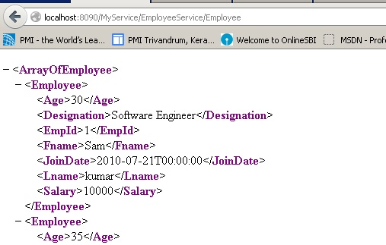

If we need to get specific employee details, pass the employee as query parameter as we mention in UriTemplate of the service.

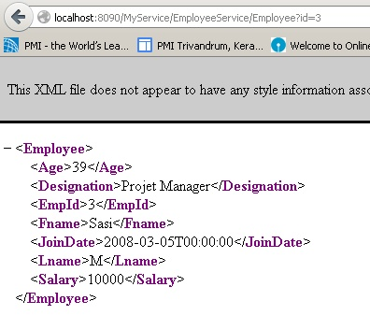

**Step 8:**Now we can start with client application. For this example we can create a console application to read the employee information and add new employee to the server resource. Below code first read the employee details from the server and add new employee and once again it read the employee details to confirm the added resource.

WebChannelFactory < IEmployeeService > cf =

new WebChannelFactory< IEmployeeService >(

new Uri("http://localhost:8090/MyService/EmployeeService"));

IEmployeeService client = cf.CreateChannel();

var d = client.GetEmployee(1);

//Load all the Employee from the server and display

foreach (Employee e in client.GetAllEmployeeDetails() )

{

Console.WriteLine(string.Format("EmpID:{0}, Name:{1} {2}",e.EmpId ,e.Fname ,e.Lname ));

}

//Add new user

client.AddEmployee(new Employee() { EmpId = 11, Fname = "John", Lname = "J", JoinDate = new DateTime(2010, 7, 24), Age = 34, Salary = 10000, Designation = "Software Engineer" });

Console.WriteLine("******************After adding new user ****************");

//Load all the Employee from the server and display

foreach (Employee e in client.GetAllEmployeeDetails() )

{

Console.WriteLine(string.Format("EmpID:{0}, Name:{1} {2}",e.EmpId ,e.Fname ,e.Lname ));

}

Console.ReadLine();

}

**Step 9:** Run the application to view the output as shown below

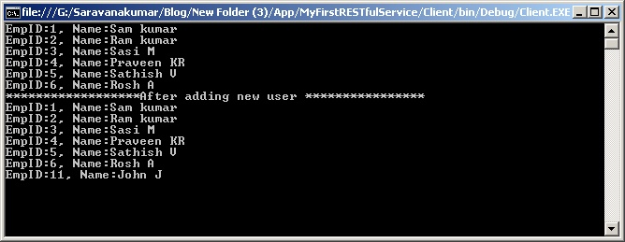

# JSON using WCF service

### Download Souce:

[MyFirstRESTfulService.zip](http://www.wcftutorial.net/Attachments/MyFirstRESTfulService.zip)

This article explains about configuring the WCF service to send the response business entity as JSON objects.

**JSON –JavaScript Object Notation**.

“The JSON text format is syntactically identical to the code for creating JavaScript objects “.

In most of the browser based application, WCF can be consumed using javascript or jquery. When client makes the call to the WCF, JSON or XML is used for mode of communication. WCF has option to send the response in JSON object. This can be configured with ***WebGet*** or ***WebInvoke*** attribute.

In this sample we can create the sample RESTful service to expose the method to read/add/update/delete the employee information. Read the [“How to create REST ful Service”](http://www.wcftutorial.net/How_to_create_RESTful_Service.aspx) articles for more information.

On top of the Restful service we need to update the ResponseMode attribute to send the business entity as JSON object. Below code shows how to configure the JSON response format.

[ServiceContract()]

public interface IEmployeeService

{

[WebGet(UriTemplate = "Employee", ResponseFormat=WebMessageFormat.Json )]

[OperationContract]

List < Employee > GetAllEmployeeDetails();

[WebGet(UriTemplate = "Employee?id={id}", ResponseFormat = WebMessageFormat.Json)]

[OperationContract]

Employee GetEmployee(int Id);

[WebInvoke(Method = "POST", UriTemplate = "EmployeePOST", ResponseFormat = WebMessageFormat.Json, RequestFormat = WebMessageFormat.Json)]

[OperationContract]

void AddEmployee(Employee newEmp);

[WebInvoke(Method = "PUT", UriTemplate = "EmployeePUT", ResponseFormat = WebMessageFormat.Json, RequestFormat = WebMessageFormat.Json)]

[OperationContract]

void UpdateEmployee(Employee newEmp);

[WebInvoke(Method = "DELETE", UriTemplate = "Employee/{empId}", ResponseFormat = WebMessageFormat.Json)]

[OperationContract]

void DeleteEmployee(string empId);

}

You can see that WCF response are send as JSON object while accessing data using browser.

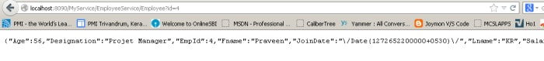

Below sample is the ASP.Net web application is used to explains about the CRUD from WCF service with response as JSON object.

**GET Method**

function RefreshPage() {

var serviceUrl = "http://saravana:8090/MyService/EmployeeService/Employee";

$.ajax({

type: "GET",

url: serviceUrl,

dataType: 'json',

contentType: "application/json; charset=utf-8",

success: function (data) {

var itemRow = "< table >";

$.each(data, function (index, item) {

itemRow += "<tr><td>" + item.EmpId + "</td><td>" + item.Fname + "</td></tr>";

});

itemRow += "</table>";

$("#divItems").html(itemRow);

},

error: ServiceFailed

});

}

**POST Method**

function POSTMethodCall() {

var EmpUser = [{ "EmpId": "13", "Fname": "WebClientUser", "Lname": "Raju", "JoinDate": Date(1224043200000), "Age": "23", "Salary": "12000", "Designation": "Software Engineer"}];

var st = JSON.stringify(EmpUser);

debugger;

$.ajax({

type: "POST",

url: "http://saravana:8090/MyService/EmployeeService/EmployeePOST",

data: JSON.stringify(EmpUser),

contentType: "application/json; charset=utf-8",

dataType: "json",

success: function (data) {

// Play with response returned in JSON format

},

error:ServiceFailed

});

}

<

**PUT Method**

function PUTMethodCall() {

var EmpUser = [{ "EmpId": "3", "Fname": "WebClientUser", "Lname": "Raju", "JoinDate": Date(1224043200000), "Age": "23", "Salary": "12000", "Designation": "Software Engineer"}];

$.ajax({

type: "PUT",

url: "http://saravana:8090/MyService/EmployeeService/EmployeePUT",

data: EmpUser,

contentType: "application/json; charset=utf-8",

dataType: "json",

success: function (data) {

// Play with response returned in JSON format

},

error: ServiceFailed

});

}

**DELETE Method**

function DELETEMethodCall() {

$.ajax({

type: "DELETE",

url: "http://saravana:8090/MyService/EmployeeService/Employee/2",

data: "{}",

contentType: "application/json; charset=utf-8",

dataType: "json",

success: function (data) {

// Play with response returned in JSON format

},

error: function (msg) {

alert(msg);

}

});

}

# WCF Security

This article explains about the security system available in WCF service. When WCF service is created, it is required to secure the service so that only required client can consume the service. This will make sure that communication channel between client and service is secured.

1. [Types Of Authentication](http://www.wcftutorial.net/Types_of_Authentication.aspx)
2. [Transfer Security Mode](http://www.wcftutorial.net/Transfer_Security_Mode.aspx)
3. [Transport Security Protection Level](http://www.wcftutorial.net/Transport_Security_Protection_Level.aspx)
4. [Message Security Level](http://www.wcftutorial.net/Message_Security_Level.aspx)

# Types of Authentication

WCF Authentication is basically referred to the verification of the caller who claims to the call the service. Verification of caller will be referring as service authentication. WCF offers various authentication mechanisms

#### No authentication:

Service does not authenticate its caller and it will allow all clients to access.

#### Windows authentication:

Services use Kerberos when a windows domain service is available or NTLM when deployed in workgroup configuration. In this mode caller provides the windows credential tickets/token to the service authentication.

#### UserName/Password:

Explicit username and password is provided to authenticate the service.

#### X509 certificates:

In this mode of security, client will send his certificate information to the service communication. Service host will check and validate the caller certificate information to authenticate the service.

#### Custom mechanism:

WCF allows developers to replace the build-in authentication mechanism by providing user own protocol and credential type for authentication.

#### Issue token:

The caller and the service can both rely on a secure token service to issue the client a token that service identify and trust. E.g windows card space

# Transfer Security Mode

When we talk about the client server secured communication, we have consider the three aspects to transfer security

1. Message integrity – it ensures that message used in communication is not tampered by any malicious party.
2. Message privacy – It ensures confidentiality of the msessage so that no third part can even read the message.
3. Transfer security – it ensures that only authenticated user can able to read the content of the message.

WCF supports five different modes of transfer security to accomplish above three aspects.

**No transfer security mode:**

This ensure that no security is applied while communication between server and client

<wsHttpBinding >

<binding name="WCFSecurityExample">

<security mode="None"/>

</binding>

</wsHttpBinding>

**Transport security mode:**

When system is configured with ‘Transport’ mode, WCF uses secured communication protocol. The available secure transports are HTTPS, TCP, IPC and MSMQ. Transport security encrypts all communication on the channel and provides integrity, privacy and mutual authentication. It provides point-to-point security.

One of main disadvantage is that it can only guarantee transfer security point-to-point, meaning it secure only at channel level. Message inside the channel will not get secured. In case of distributed communication, multiple intermediaries between service and client will not be secure.

It is mainly used in intranet application

<wsHttpBinding >

<binding name="WCFSecurityExample">

<security mode="Transport"/>

</binding>

</wsHttpBinding>

**Message security mode:**

In this mode of configuration, message will get encrypted. Encrypting the message rather than transport enables the service to communicate securely over non secure transport such as HTTP. It provides end-to-end security.

One of the disadvantages of message security is that it may introduce call latency due to its inherent overhead.

It is mainly used in internet application.

<wsHttpBinding >

<binding name="WCFSecurityExample">

<security mode="Message"/>

</binding>

</wsHttpBinding>

**Mixed transfer security mode:**

It uses Transport security for message integrity, privacy and service authentication and it uses Message security for securing client credential.

One of disadvantage of the mixed mode is that it will secure only point-to-point as nature of Transport security.

<wsHttpBinding >

<binding name="WCFSecurityExample">

<security mode="TransportWithMessageCredential"/>

</binding>

</wsHttpBinding>

**Both security modes:**

This mode Both transfer security mode uses both Transport security and Message security. So message is secured using Message security and then it is transferred to the service using secure transport. This mode will maximize the security but overload the performance.

<netMsmqBinding >

<binding name="WCFSecurityExample">

<security mode="Both"/>

</binding>

</netMsmqBinding>

|  |  |  |  |  |  |
| --- | --- | --- | --- | --- | --- |
| **Name** | **None** | **Transport** | **Message** | **Mixed** | **Both** |
| BasicHttpBinding | Yes(default) | Yes | Yes | Yes | No |
| NetTcpBinding | Yes | Yes(default) | Yes | Yes | No |
| NetNamedPipeBinding | Yes | Yes(default) | No | No | No |
| WsHttpBinding | Yes | Yes | Yes(default) | Yes | No |
| WsDualHttpBinding | Yes | No | Yes(default) | No | No |
| NetMsmqHttpBinding | Yes | Yes | Yes(default) | No | Yes |

# Transport Security Protection Level

This article explains about the how to configure the service with Transport security settings and what are the protection level available.

When configure transfer security for Transport security, not all bindings support all client credential type

Below table list client credential for different binding

|  |  |  |  |  |
| --- | --- | --- | --- | --- |
| **Name** | **None** | **Windows** | **Username** | **Certificate** |
| BasicHttpBinding | Yes(default) | Yes | Yes | Yes |
| NetTcpBinding | Yes | Yes(default) | No | Yes |
| NetNamedPipeBinding | No | Yes(default) | No | No |
| WsHttpBinding | Yes | Yes(default) | Yes | Yes |
| WsDualHttpBinding | N/A | N/A | N/A | N/A |
| NetMsmqHttpBinding | Yes | Yes(default) | No | Yes |

Below diagram explain about how set the client credential in configuration file

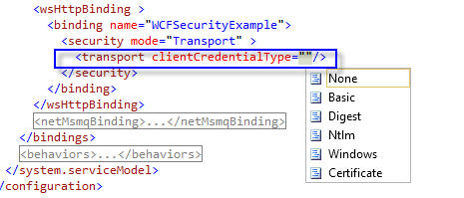

While developing Intranet application, it is good to go with Transportnode for transfer security because calls are invariably point-to-point.

In NetTcpBinding/NetNamedPipeBinding/NetMsmqBinding supports three level of protection to transfer message

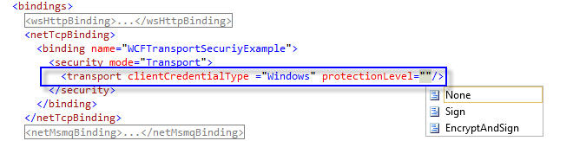

>

* **None:** Message does not get protected while transfer from client and service
* **Signed:** this protection level make sure that message is received from authenticated user, but it message can be tampered by any third party.
* **Encrypted and Signed:** This level makes sure that message is received from authenticated user and it also encrypts the message

# Message Security Level

This article explains about the how to configure the service with Message security settings and what are the client credential available for this mode.

When configure transfer security for Message security, not all bindings support all client credential type

Below table list client credential for different binding

|  |  |  |  |  |  |
| --- | --- | --- | --- | --- | --- |
| **Name** | **None** | **Windows** | **Username** | **Certificate** | **Issued token** |
| BasicHttpBinding | No | No | No | Yes | No |
| NetTcpBinding | Yes | Yes(default) | Yes | Yes | Yes |
| NetNamedPipeBinding | N/A | N/A | N/A | N/A | N/A |
| WsHttpBinding | Yes | Yes(default) | Yes | Yes | Yes |
| WsDualHttpBinding | Yes | Yes(default) | Yes | Yes | Yes |
| NetMsmqHttpBinding | Yes | Yes(default) | Yes | Yes | Yes |

Below diagram explain about how set the client credential in configuration file

